TEAM PROJECT REPORT

Energy Storage Devices Based Upon 3D Graphene: Case Supercapacitors and Lithium-Sulfur (LiS) Batteries

Submitted To

The 2018 RET Site
For

“Engineering Design Challenges and Research Experiences for Secondary and Community College Teachers”

Sponsored By
The National Science Foundation
Grant ID NO.: EEC-17110826

College of Engineering and Applied Science
University of Cincinnati, Cincinnati, Ohio

Prepared By
Participant #1: Aaron Debbink, Physics, High School, Indian Hill High School, Cincinnati, Ohio
Participant #2: Megan Stafford, Math, High School, Holmes High School, Covington, Kentucky

Approved By
____________________________________

Dr. Noe Alvarez
Dr. Vesselin Shanov
Chemical and Materials Engineering
College of Engineering and Applied Science
University of Cincinnati

Reporting Period: June 11, 2018 - July 27, 2018

Abstract

There is a growing interest in the development of energy-dense flexible batteries which can power the growing number of wearable electronic devices. Lithium-sulfur (Li-S) chemistry has a high theoretical energy density, but sulfur can be inflexible and brittle. Also, full utilization of the active sulfur material for the electrochemistry is limited by sulfur’s low electrical conductivity. One approach used to increase the mechanical strength and electrical conductivity was to incorporate sulfur into a conductive matrix. For this research sulfur was incorporated into a carbon nanotube (CNT) thread and combined with a densified CNT thread to overcome the inflexibility, low mechanical strength, and low electrical conductivity of sulfur. The tensile strength of the individual fibers was evaluated. The hybrid cathode was used in a coin cell battery and the cathode electrical conductivity was evaluated using electrochemical impedance spectroscopy.

Key Words - Carbon nanotube thread, Carbon nanotube fiber, Coin battery, Electrical conductivity, Fiber battery, Lithium- Sulfur battery, Sulfur Cathode Composite, Wearable fiber battery

1. INTRODUCTION

The use of batteries to store electrical energy is widely used for portable electronics and increasingly in the automotive industry for transportation. Batteries are also starting to be used as temporary energy storage for wind and solar power generation. Ongoing efforts are being made to improve the performance of batteries in order to reduce the cost and weight in many applications. Research in this area is focused on making batteries, which are safe, have a high energy-density or specific energy, a high specific power, and a long cycle life.

With the growing numbers of wearable electronic devices, there is an increased interest in the development of flexible energy-efficient batteries. The most widely used and commercially available battery chemistry is lithium-ion. This battery chemistry has been widely used because lithium-ion batteries offer higher energy density, specific power, and longer cycle life than lead batteries. In spite of these advantages, lithium-ion batteries do not offer the desired flexibility nor safety needed for wearable electronic devices.

Lithium-sulfur batteries offer an alternate chemistry, which has higher theoretical specific energy and specific power than lithium-ion batteries. However, lithium sulfur batteries also have limitations which need to be overcome. Sulfur has a high theoretical specific energy, but it’s low conductivity limits the full use of the sulfur as active material for the electrochemical reactions. Also, some of the active sulfur material becomes dissolved as polysulfides in the battery’s electrolyte. The dissolved polysulfides lead to undesirable chemical reactions, which render the sulfur unavailable for additional electrochemical reactions. As the battery is charged and discharged through repeated cycles the growing inactive sulfur quickly reduces the overall life span of the battery. Current research of lithium-sulfur batteries has focused efforts to increase the conductivity of the sulfur cathode and limit the movement of the dissolved polysulfides. This research can then lead to the development of electrochemical batteries which can perform while stretched, flexed, or twisted and can be woven into fiber-based materials.

2. LITERATURE REVIEW

Batteries are energy storage devices with 2 electrodes isolated by a separator. One of the electrodes is the electron-releasing, negative anode, and the other electrode is the electron-absorbing, positive cathode. The 2 electrodes of active material are soaked in electrolyte to allow the movement of ions between the 2 electrodes. In current battery designs there is often a compromise between increased specific energy and increased specific power. Batteries with high specific energy have a long run time for a given discharge current, and batteries with high specific power can be safely discharged with high loads (Buchmann, 2016). The load of a battery is defined as the current being drawn from the battery. Lithium has proven to have a high specific energy and high specific power ideal for batteries. Lithium batteries comprise 37% of the total worldwide battery usage, as lithium-ion batteries are preferred for portable devices and electric powertrains in vehicles. Variations to Lithium-ion batteries have the potential for even higher specific energy and specific power than conventional lithium-ion batteries (Buchmann, 2016).

The growing demand for electronic wearable products has led to the need for more advanced energy-storage systems for these portable devices. Lithium-sulfur (Li-S) batteries show great potential to fulfill this need as these batteries are low cost, environmentally friendly, and provide high energy and high power capacity. The high energy capacity is due to the sulfur cathode which has a theoretical capacity of 1672 mA h g⁻¹ and the lithium anode which has a theoretical capacity of 3860 mA h g⁻¹ (Chung et al 2015). The practicality of Li-S batteries is limited because sulfur is an insulator, which leaves much of the active sulfur material unavailable for the battery’s electrochemistry. Also, the amount of energy a Li-S battery can store severely diminishes as the battery is repeatedly charged and discharged. During repeated charge and discharge cycles, the sulfur will undergo a complex series of configuration and structure changes creating polysulfide intermediates. These polysulfide intermediates are soluble in the electrolyte and can move between the anode and the cathode during charge and discharge cycles. This polysulfide movement between the electrodes leads to a decrease of active sulfur in the cathode and the buildup of a surface passivation layer on the anode which obstructs long-term cycling. To overcome these problems for Li-S batteries, current research efforts are being made to improve the cell component materials and structures, better understand and combat the Li-S reduction and oxidation reactions, and innovate the overall cell configuration (Chung et al 2014).

To increase the availability of the active sulfur material in Li-S batteries, some research has focused on using a sulfur-based nanocomposite free-standing cathode. A sulfur-based freestanding cathode is a highly-conductive substrate preferred for its innate flexibility and lightweight characteristics. A freestanding cathode is not bulky like other binders and electrode designs due to the high porosity and use of a carbon substrate to decrease the device’s overall weight. The superior cell performance of higher conductivity and specific capacity can be attributed to the encapsulation of the active sulfur material to limit polysulfide movement between the electrodes and increase the device’s cyclability and overall stability. A porous carbon substrate of CNTs can assist with redox accessibility of the active sulfur (Ji and Nazar 2010). While a higher sulfur content will lead to even higher specific capacity, increased sulfur can cause the CNT threads to become brittle, and thereby compromise the feasibility of using the freestanding cathode. Therefore, the amount of sulfur must be considered with the weight of the carbon substrate when constructing a free-standing cathode. The high cyclability, low weight, and flexibility of a freestanding composite cathode make it ideal for fiber-shaped batteries (Chung et al 2015).

The necessity for a fiber-shaped battery is continuously growing as the demand for products like the Apple Watch, Fitbit, or Samsung Gear progressively increases. Fiber batteries need to be flexible and have a high specific energy capacity. Conventional lithium-ion batteries cannot provide this flexibility as they are rigid, bulky, and planar (Zhang et al 2016). Fiber-shaped batteries must be able to bend, stretch, and twist to conform to the natural movement of the human body. A freestanding sulfur-loaded cathode using carbon nanotubes has shown to not break under such conditions. This free-standing sulfur-loaded cathode is also considered breathable making it an ideal component for wearable electronic products (Zhang et al 2016). To properly fabricate a wearable fiber-shaped battery the electrochemically active material present within the cathode of the Li-S battery must stay anchored to the supporting CNT substrate. If the active material is unable to stay anchored the theoretical high capacity of Li-S batteries is diminished and the battery is unable to perform as expected. To this end, carbon nanomaterials are primarily used as the components of the electrodes for fiber-shaped, portable batteries because of the high surface areas leading to excellent stability (Zhang et al). A significant limitation of CNT fiber lithium-ion batteries is their high resistance. The electrical resistance of a CNT fiber lithium-ion battery using current technologies limits the length to only tens of centimeters before the electrical performance drops. Lastly, any fiber battery design must also be washable, comfortable, and safe (Zhang et al 2016).

3. GOALS AND OBJECTIVES

The goal of this research project was to create a flexible cathode for a lithium-sulfur fiber battery which has a high conductivity and tensile strength. To achieve this goal, there were 4 objectives as follows; (1) learn how to synthesize a sulfur loaded CNT thread, (2) learn how to densify CNT thread, (3) assemble a hybrid thread using a sulfur-loaded CNT thread and a densified CNT thread, (4) use the hybrid thread as the cathode in the assembly of a coin cell battery to test for practical functionality in a lithium-sulfur fiber battery.

4. RESEARCH STUDY DETAILS

For this research, the RET participants needed to become familiar with the process of creating a CNT cathode from a spinnable CNT array. Both RET participants spent considerable time reading literature about CNTs, observing the CNT thread creation process numerous times, and recording proper parameters for each step. Once this process was well understood, RET participants were able to take part in the creation of a CNT cathode.

4.1 Synthesis of Hybrid Cathode for Fiber Battery

A hybrid cathode consists of a sulfur-loaded CNT thread spun together with a densified CNT thread. These 2 threads are both created from pristine CNT threads, which are spun from vertically-aligned spinnable CNT arrays made on silicon wafers using Chemical Vapor Deposition (CVD). The pristine CNT threads are then modified to create the sulfur-loaded and densified CNT threads needed for the hybrid thread.

4.1.1 Synthesis of CNT Thread

Spinnable CNT arrays are first created by the Nanoworld Lab using chemical vapor deposition. Once spinnable CNT arrays are made they are placed on an adjustable platform situated in line with a spinning mechanism. The front of each array is manually pulled off the silicon wafer and twisted together to begin making a single CNT thread. This manually-twisted thread is placed on an aluminum bobbin and the spinning mechanism is turned on. The spinning mechanism both pulls and rotates the thread at constant rates, as shown in Figure 1. The spinning mechanism can be set to different pulling rates and rotational speeds. A pulling rate of 4.78 millimeters/second, and a spinning rate of 1080 rpm, was used throughout this research. These pristine CNT threads can be created from 2 or 3 spinnable CNT arrays depending upon the desired diameter. The pristine CNT thread is then modified to create a sulfur-loaded CNT thread or a densified CNT thread. More details about spinnable CNTs and threads could be found in literature published by Nanoworld (Alvarez et al 2015).

Figure 1. Schematic illustration of spinning a CNT thread.

4.1.2 Synthesis of Sulfur-loaded CNT Thread

Sulfur cannot be adequately introduced to a pristine CNT thread without first introducing defects to the hydrophobic carbon structure. These defects are introduced to the pristine CNT thread through oxygen plasma functionalization, as show in Figure 2. This process causes defects to the individual carbon nanotubes in the CNT thread and creates functional groups which allow sulfur to attach to the outside and inside of the CNT. The oxygen plasma functionalization also changes the CNT thread from hydrophobic to hydrophilic, ideal for sulfur melting infiltration. First an aluminum bobbin containing pristine CNT thread is placed onto a bobbin holder. The CNT thread is then weaved through the chamber using a copper wire and secured onto a new aluminum bobbin. The power supply will be winding the CNT thread onto the new aluminum bobbin with the power supply to the motor set at 5.5V. The oxygen plasma functionalization parameters will be set to a power of 100W, helium will be set to 15.0L per minute, and the oxygen will be set to 0.3L per minute. Once the pristine CNT thread has undergone oxygen plasma functionalization the CNT thread is manually removed and neatly folded by hand. The mass of this CNT thread is obtained and sulfur is then measured in a 5:1 ratio, sulfur to CNT. The sulfur and oxygen plasma functionalized CNT thread are placed into a steel autoclave with an airtight Teflon inner chamber. The autoclave is then stored in an iso-temperature oven set to 155°C overnight and cooled the following morning. After the sulfur-loaded CNT thread has cooled it is removed from the autoclave and weighed. The percentage of sulfur compared to the total weight after sulfur-loading is then calculated with an ideal percentage between 60-70%. The sulfur-loaded thread can be further characterized by a desktop scanning electron microscope to measure the diameter and view how the sulfur attached to the CNT thread. This sulfur-loaded CNT thread can be used for a cathode or it can be combined with a densified thread to make a hybrid CNT thread cathode.

Figure 2. Schematic illustration of oxygen plasma functionalization

4.1.3 Synthesis of Densified CNT Thread
Creating a densified CNT thread from a pristine CNT thread can increase the tensile strength and the conductivity of the cathode. The densified CNT thread is created from a pristine CNT thread that is soaked in acetone and then spun onto a new bobbin. The pristine CNT thread will soak in acetone for 3 hours in order to bring the CNTs closer together and thereby, densify the thread. After the 3 hours has elapsed the spinning mechanism will be used to unwrap the CNT thread from the bobbin submerged in acetone and rewrap it onto a new bobbin, as shown in Figure 3. By rewrapping the CNT thread onto a new bobbin, the entire thread is exposed to the acetone and more uniformly densified. The CNT thread is further characterized using the scanning electron microscope. It is desired for the densified CNT thread to be have a larger diameter than the sulfur-loaded CNT thread in order to achieve an increased tensile strength.

4.1.4 Synthesis of Hybrid Cathode

The goal to create a cathode with a high conductivity and tensile strength was further investigated by the creation of a hybrid CNT thread cathode. The hybrid cathode consists of a sulfur-loaded CNT thread spun together with a densified CNT thread to create a uniformly twisted structure schematically shown in Figure 4. Similar to spinning a pristine CNT thread, the hybrid CNT thread is also spun using the same spinning mechanism. The pulling and spinning rates were altered using various combinations in order to achieve the most uniform hybrid thread which was characterized using the desktop scanning electron microscope.

4.2 Characterization of Hybrid Cathode

Selected CNT threads were characterized to measure diameters, view the presence of sulfur, and view the structure of the hybrid CNT thread using microscopy techniques. The characterization provides visual support for adequate construction of a properly spun hybrid CNT thread when using different pulling and spinning rates. The hybrid threads were further characterized to determine the relative cathode resistance and specific capacity.

4.2.1 Scanning Electron Microscopy

The morphology of the CNT threads was determined using a scanning electron microscope (SEM) (TM3000) (Appendix III;1). The SEM can magnify from x15 to x30,000. Selected CNT threads were prepared on the SEM metal stage and observed using various magnifications of the SEM in order to obtain proper measurements. The SEM images were examined for shape, size, and uniformity. Diameters of the CNT threads were measured and comparisons were made between the densified CNT thread and sulfur-loaded CNT thread.

4.2.2 Electrochemical Impedance Spectroscopy

Electrochemical Impedance Spectroscopy (EIS) (Gamry EIS300) (Appendix III; 2) was used to characterize the resistance of the CNT thread cathodes within a coin cell battery. This resistance testing helped to evaluate the conductivity of the cathodes, as a lower resistance is indicative of higher conductivity. EIS utilizes a small amplitude, alternating current signal to probe the electrochemical characteristics of a coin cell battery including impedance or resistance ("EIS-Electrochemical Impedance Techniques" 2018). The resistance for coin cell batteries containing sulfur-loaded CNT thread cathodes and hybrid CNT thread cathodes were obtained using the 4 electrode probe setup for EIS.

4.2.3 Tensile Strength

Tensile strength of the CNT threads was characterized by the universal, static testing system Instron 5948 (Appendix III; 3). This single column table top system is ideal for tensile strength testing. Sulfur-loaded CNT threads and densified CNT threads were characterized using this Instron system to obtain information about the tensile strength.

4.2.4 Battery Cycling Testing

The performance of the CNT thread cathodes were characterized in coin cell batteries using a battery analyzer (MTI BST8-MA 8 Channel Battery Analyzer) (Appendix III; 4). This analyzer further evaluates the cathode’s specific capacity over repeated cycling of the battery. There are 8 battery channels each possessing independent constant-current and constant-voltage sources controlled and programmed by the supporting computer software. The coin cell batteries undergo analysis at different charging and discharging current rates, or C- rates, to measure the specific discharge capacity during repeated charge and discharge cycles.

5. RESEARCH RESULTS AND DISCUSSION

5.1 Assembly of hybrid CNT Threads

Sulfur-loaded CNT threads and densified CNT threads were spun together to prepare a hybrid thread (yarn). Using these materials, hybrid CNT threads were able to be synthesized and used as cathodes in coin cell batteries.

5.2 Characterization of Hybrid CNT Threads

After the sulfur-loaded, densified, and hybrid CNT threads had been assembled, these threads were characterized using the SEM. The general distribution of sulfur, the thread diameters, and the hybrid structure were visualized. The hybrid threads were further characterized to determine the relative cathode resistance and specific capacity.

5.2.1 Characterization of Sulfur-loaded CNT Threads

Sulfur-loaded CNT threads were synthesized from pristine CNT threads after oxygen plasma functionalization and sulfur melting infiltration. The weight of sulfur present on the synthesized sulfur-loaded CNT threads varied between 49.2% and 66.5%, compared with the desired range of 60-70%. After sulfur melting infiltration, the sulfur-loaded CNT threads were characterized by SEM and the diameters were measured, as seen in Figure 5. The sulfur-loaded CNT threads with larger diameters had an increased percentage of sulfur present. The threads containing more sulfur were more brittle and more easily tangled as compared to sulfur-loaded CNT threads with less sulfur.

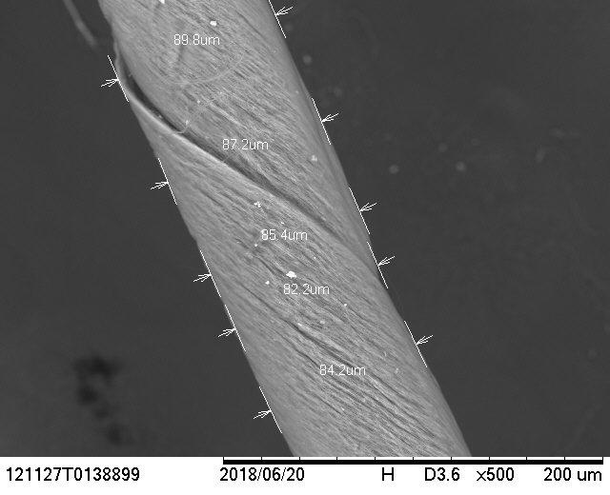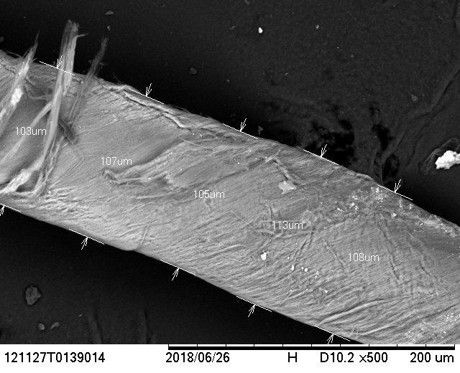

Figure 5. SEM Images of Sulfur-loaded CNT Threads

5.2.2 Characterization of Densified CNT Threads

Densified CNT threads were prepared from pristine CNT thread. These threads were synthesized from spinning 2 or 3 CNT arrays and then subsequently soaked in acetone for 3 hours. The threads made from 3 arrays were preferred as they had a larger diameter leading to increased strength.

5.2.3 Characterization of Hybrid CNT Threads

Hybrid CNT threads were assembled from sulfur-loaded CNT threads and densified CNT threads by using the spinning mechanism at varied pulling and spinning rates, as seen in Figure 6. A pulling rate of 1.6 mm/s and a spinning rate of 1,600 rpm proved to create a hybrid thread with undesired bunching, or tangling, of the densified and sulfur-loaded CNT threads (Figure 6a). Whereas a pulling rate of 1.9 mm/s and a spinning rate of 1,310 rpm did not cause bunching but was not uniformly spun (Figure 6b). Instead, at these rates, the sulfur-loaded CNT thread and the densified CNT thread were observed to be randomly spun around each other, alternating which thread was primarily wrapped around the other. A pulling rate of 1.2 mm/s and a spinning rate of 1,310 rpm proved to provide uniformity of the densified CNT thread wrapped around the sulfur-loaded CNT thread (Figure 6c). This pattern of wrapping likely occurred as the sulfur-loaded CNT thread had a larger diameter than the densified CNT thread. While these pulling and spinning rates provided the best uniformity, it is preferred for the sulfur-loaded CNT thread to be wrapped around the densified CNT thread in order for the maximum load to be placed on the stronger, densified CNT thread and increase the hybrid cathode tensile strength.

a) 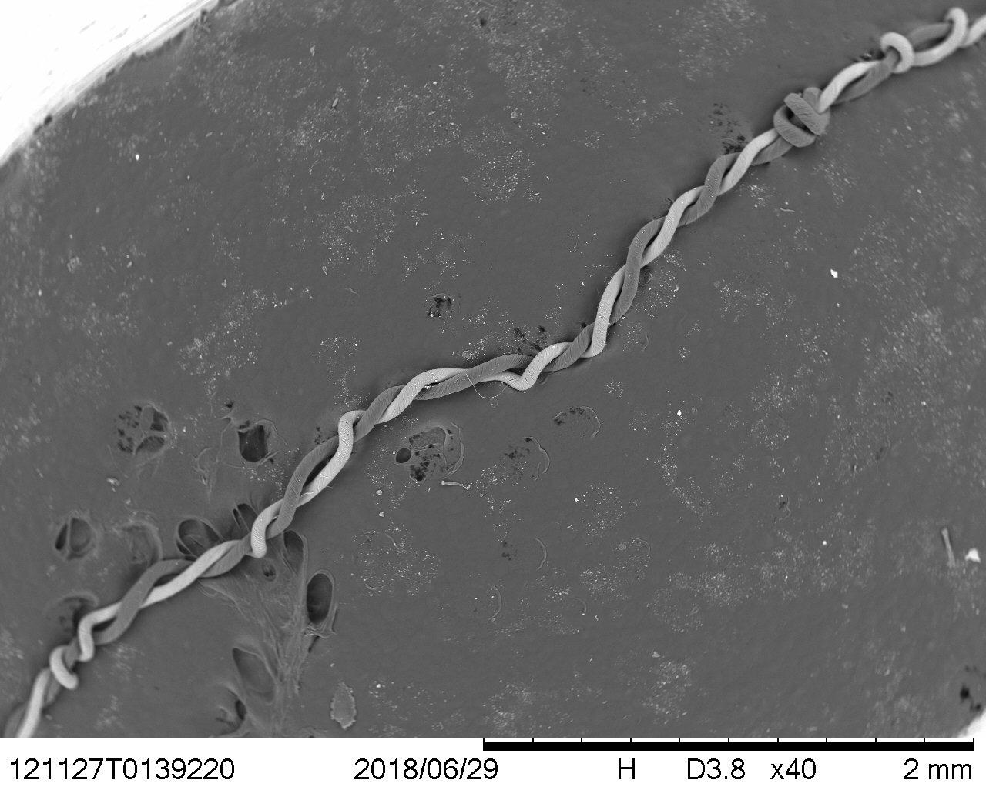 b)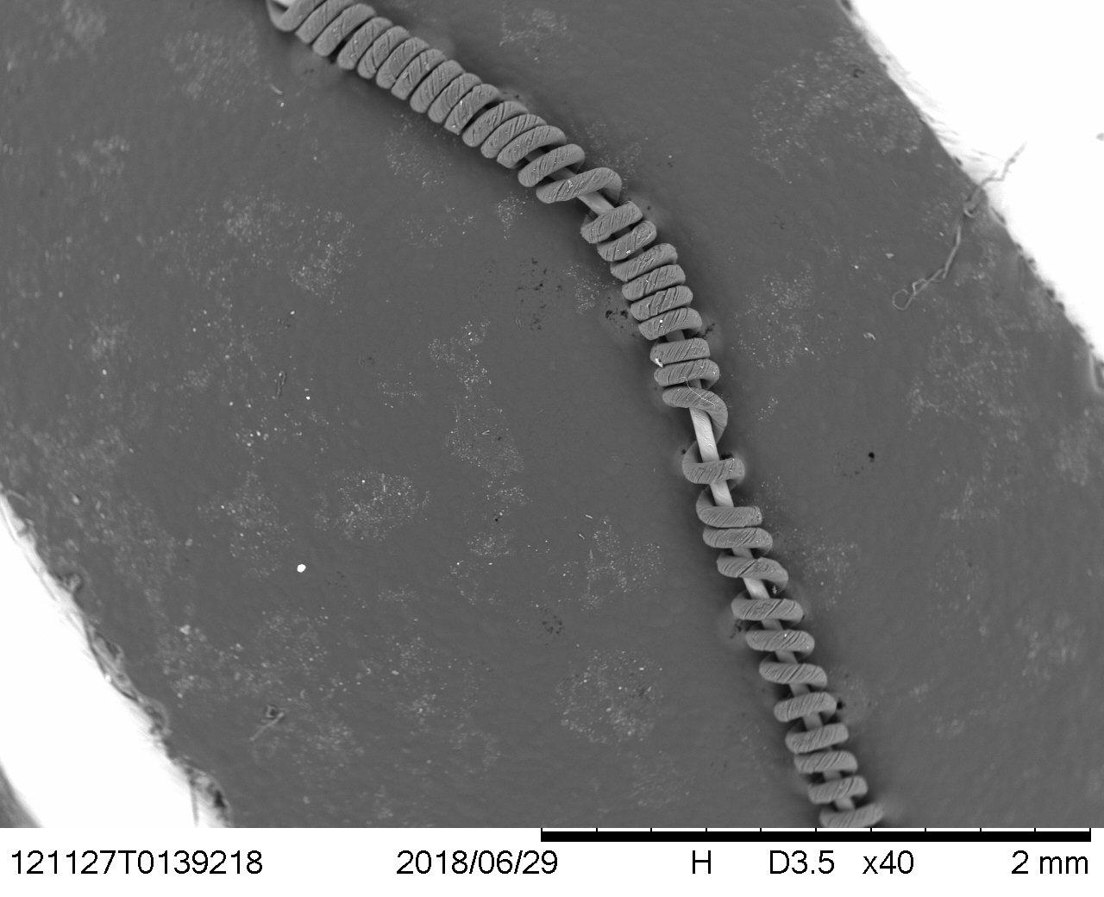
c)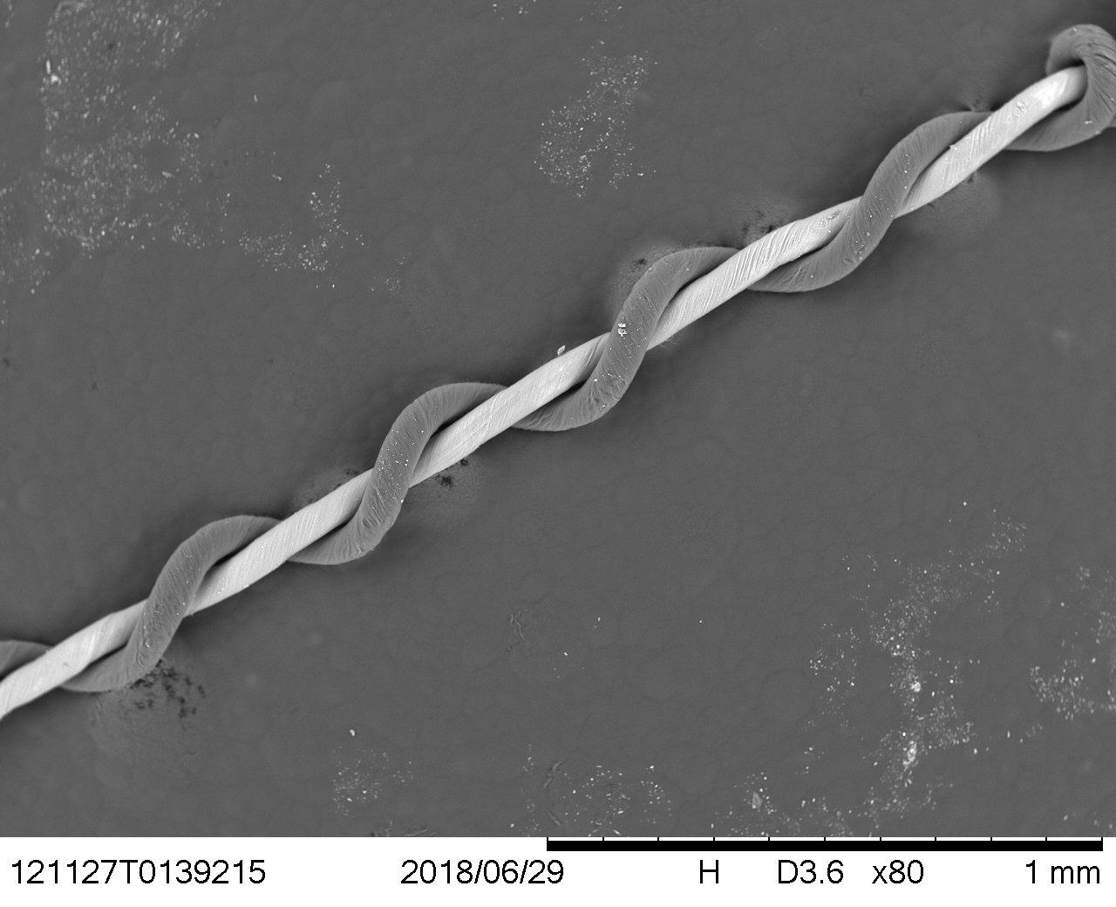
Figure 6. Hybrid CNT threads. a) pulling rate of 1.6 mm/s and a spinning rate of 1,060rpm. b) pulling rate of 1.9 mm/s and a spinning rate of 1,310 rpm. c)pulling rate of 1.2 mm/s and a spinning rate of 1,310 rpm

5.2.4 Electrochemical Impedance Spectroscopy Testing

Coin cell batteries containing sulfur-loaded CNT thread cathodes and hybrid CNT thread cathodes were assembled. EIS testing was then completed on both cathodes, as shown in Figure 7. The coin cell containing the sulfur-loaded cathode was found to have an electrolyte and electrode resistance of 989 ohms, and the coin cell containing the hybrid cathode had an electrolyte and electrode resistance of only 32.8 ohms. The hybrid cathode resistance was found to be approximately 30x less than the original sulfur-loaded cathode. Therefore, the hybrid CNT thread cathode is 30x more conductive than the sulfur-loaded CNT thread cathode.
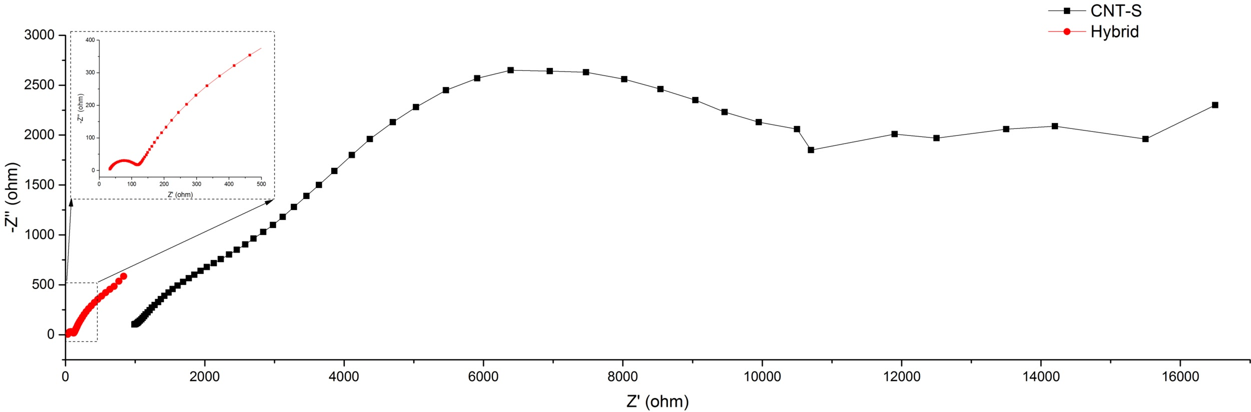

Figure 7. EIS testing for sulfur-loaded CNT thread and hybrid CNT thread

5.2.5 Tensile Strength Testing

The sulfur-loaded CNT threads and densified CNT threads were used for tensile strength testing. The densified CNT thread was shown to have a 1.4x higher tensile strength when compared to the sulfur-loaded CNT thread, as shown in Figure 8. The tensile strength of a hybrid CNT thread cathode with both the sulfur-loaded CNT thread wrapped around the densified CNT thread would be greater than a cathode with only the sulfur-loaded CNT thread with the same cross-sectional area.

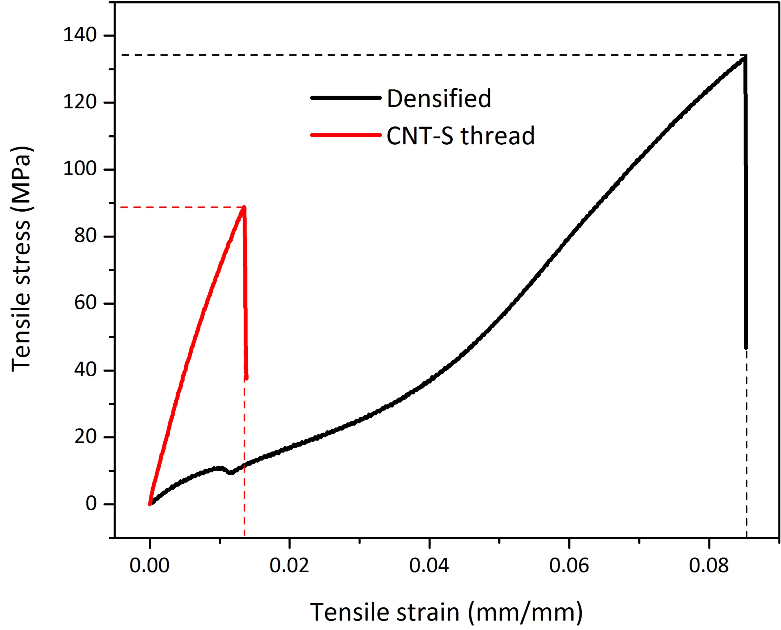

Figure 8. Tensile Strength Testing

5.2.6 Battery Cycling Testing

Coin cell batteries with sulfur-loaded CNT thread cathodes and hybrid CNT thread cathodes were assembled. These coin cell batteries were then used for battery cycling testing at different currents, or C-rates, as shown in Figure 9. This testing demonstrated a significantly higher capacity for the hybrid thread cathode for the first 5 cycles at the lowest current. As the cycling testing continued at higher currents, the hybrid CNT thread cathode continued to have an overall higher capacity as compared to the sulfur-loaded CNT thread cathode.
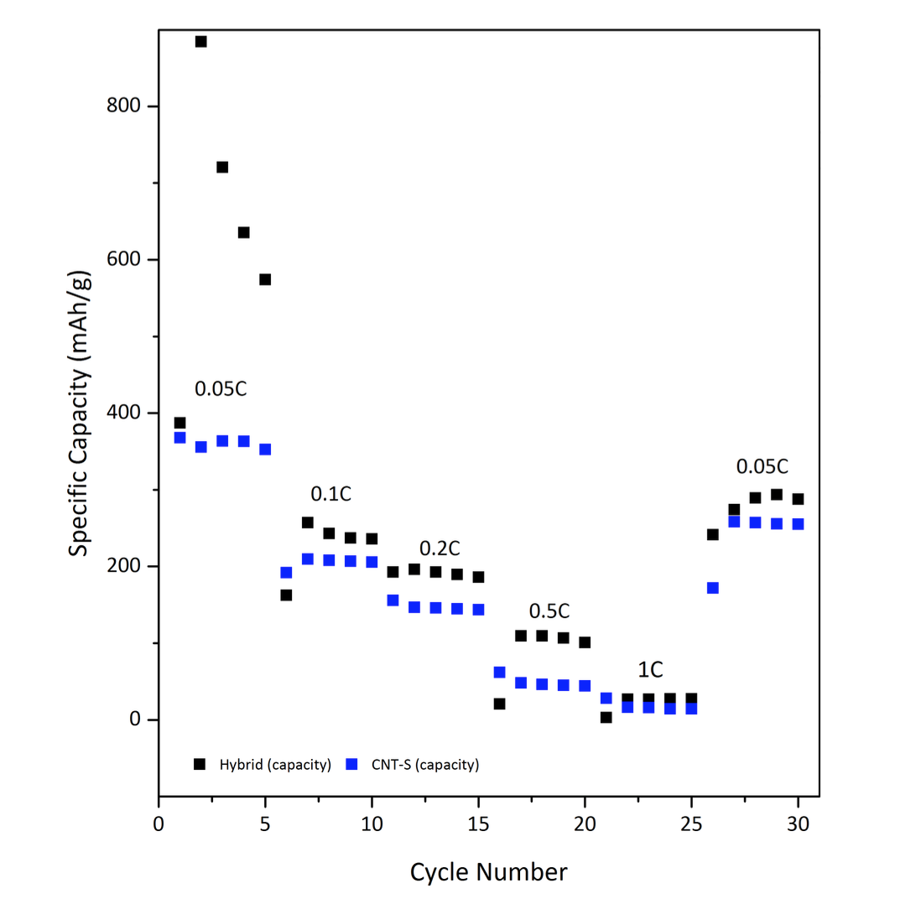

Figure 9. Battery Cycling Testing

6. CONCLUSIONS

The goal of assembling a flexible cathode for a lithium-sulfur battery with a higher conductivity and tensile strength was successful in terms of characterization testing of the hybrid CNT thread cathode as compared to the sulfur-loaded CNT thread cathode. The EIS testing showed increased conductivity of the hybrid CNT thread cathode by demonstrating a decrease in the resistance of the cathode. The battery cycling testing showed increased capacity over various charging and discharging cycles. Obtaining higher tensile strength for the hybrid cathode was successful through tensile testing. This testing showed the densified CNT thread to have a higher tensile strength than the original sulfur-loaded CNT thread and by combining the densified and sulfur-loaded CNT threads a higher tensile strength will be achieved. Additionally, the tensile strength testing showed the densified CNT thread could be stretched up to 5x more than the sulfur-loaded CNT thread before breaking, making the hybrid thread more functional for a fiber battery.

7. RECOMMENDATIONS

Recent efforts were aimed at increasing the electrical conductivity of the sulfur-based cathode of lithium-sulfur batteries. Further configurations of the cell components can be investigated in order to better capture the high theoretical capacity sulfur offers. Recommendations for future research also include different methods for synthesizing hybrid CNT thread cathodes with the sulfur-loaded CNT thread wrapped around the densified CNT thread. This could be further investigated by wrapping a pristine CNT thread around a densified CNT thread and then completing the sulfur-melting infiltration.

8. CLASSROOM IMPLEMENTATION PLAN

Megan’s classroom implementation is as follows. The unit that will be implemented is regarding criteria for optimal battery usage. To begin, students will be presented with several videos of sporting events, movies, and current events that will end at the climax; such as ending a video just before the winning goal of the World Cup. At the end of the videos an empty battery icon will flash as if the video cut off due to low battery. This hook will spark the students’ interest and lead into the Big Idea of battery capacity and usage. After this hook, students will analyze and evaluate their MacBook batteries to understand the MacBook’s capacity in order to create criterion for optimal use of the battery. Students will identify the main use of their school-given MacBook. Usage will range from school purposes to personal use to games or movies. Once students have identified the main use of their MacBooks, Lesson 1 will begin with the teacher presenting an equation to highlight the charge and current of a battery over a period of time. Given this equation students will rearrange the equation to highlight a desired variable. As part of Lesson 1, students will be introduced to the MacBook applications that will be used during MacBook testing for Activity 2. The applications that will be used are System Information, Activity Monitor and Battery Health. During Activity 2 students will have the opportunity to navigate the MacBook applications and lead into Lesson 2 where the students will interpret and create equations using tables and graphs. This will be taught using the data students gather from the 1st round of testing. This knowledge will then be reapplied during the 2nd round of testing and comparisons will be made to assist the students in refining their optimal battery usage criteria. During round 1 of testing within Activity 3 students will work in their assigned groups and begin monitoring and recording the data about their MacBooks’ batteries. The data will be recorded into Google Sheets and these spreadsheets will be shared with the teacher to allow for formative grades to be given and progress to be checked throughout testing. Using the data from round 1, each group will develop a set of criterion for how to optimally utilize their MacBook batteries (reducing brightness, reducing sound, decreasing window size, etc.). Then during Activity 2 students will complete round 2 of testing by applying their developed criterion to improve the MacBook’s battery usage and retest their MacBook batteries using the same applications. Once students have obtained this data they will interpret their data and refine their optimal battery usage criteria. After their criterion is finalized student groups will present their data and criterion to the other groups. See Appendix IV for the unit and activity templates for Megan’s plan.

Aaron’s classroom implementation is as follows. The unit that will be implemented focuses on the evaluation of lithium ion batteries which does not compromise safety or future cell performance. Activity 1 uses the challenged-based learning (CBL) pedagogy to introduce the topic of battery evaluation to the students. In activity 1 the big idea and essential question is introduced through student investigation of disassembled laptop and power tool batteries and a YouTube video which discusses how recycled lithium-ion cells are used to store solar energy in homes. Students will be challenged to design a process to test individual lithium-ion cells to determine which cells have more usable life and which cells will need to be recycled. Activity 2 uses both direct instruction and basic inquiry involving the basics of chemical batteries: safety, charging and discharging limits, voltage ranges, and series and parallel combinations of individual battery cells. Activity 3 enables students to create a conceptual understanding and the ability to test non-ideal chemical batteries. In activity 3 students are introduced to a simplified model of a chemical battery which involves an ideal voltage source (Emf) and an internal resistor. Student lab groups will then experimentally estimate the internal resistance of the battery and the Emf and document their data and analysis. In activity 4 the students will be using the engineering design process to design a process to test individual lithium-ion cells to determine which cells have more usable life and which cells will need to be recycled. The development of the battery testing process and battery testing results will be documented in a digital form using a Google doc. After the final design of the testing process and the individual battery cell testing, each student group will present their final testing process and results. Finally, in activity 5, the students will use the tested lithium ion cells to construct a small portable battery pack which can be charged and discharged through standard USB cables.

9. ACKNOWLEDGEMENTS
The authors of this paper would like to acknowledge and thank the National Science Foundation for their financial support throughout this study. They would also like to acknowledge the guidance provided by faculty mentors Dr. Noe Alvarez and Dr. Vesslin Shanov, and their Graduate Research Assistant, Yanbo Fang. Gratitude would also like to be extended to the RET Project Director and Principal Investigator, Dr. Anant R. Kukreti, RET Resource Person and Grant Coordinator, Debbie Liberi, and RET Resource Teacher, Mrs. Pamela Truesdell. The RET program is funded by the National Science Foundation, Grant ID# EEC-17110826: “Engineering Design Challenges and Research Experiences for Secondary and Community College Teachers.” Any opinions, findings, and conclusions or recommendations expressed in this material are those of the authors and do not necessarily reflect the views of the National Science Foundation.

10. BIBLIOGRAPHY

Alvarez, N. T.; Miller, P.; Haase, M.; Kienzle, N.; Zhang, L.; Schulz, M. J.; Shanov, V., Carbon nanotube assembly at near-industrial natural-fiber spinning rates. Carbon 2015, 86, 350-357.

Buchmann, I. (2016). Batteries in a portable world: a handbook on rechargeable batteries for non-engineers. Cadex Electronics Inc., Richmond, British Columbia.

Chung, S. and Manthiram, A. (2014). High-Performance Li–S Batteries with an Ultra-lightweight MWCNT-Coated Separator. The Journal of Physical Chemistry Letters, 5(11), pp.1978-1983.

Chung, S., Manthiram, A., Zu, C. (2015). “Lithium-Sulfur Batteries: Progress and Prospects.” Advanced Materials, 27, 1980-2006.

"EIS-Electrochemical Impedance Techniques." (2018). Gamry.com, <https://www.gamry.com/application-notes/EIS/potentiostatic-eis-tutorial/> (Jul. 17, 2018).

Ji, X., and Nazar, L. (2010). "Advances in Li–S batteries". Journal of Materials Chemistry, 20(44), 9821-9826.

Manthiram, A., Fu, Y., Chung, S., Zu, C. and Su, Y. (2014). Rechargeable Lithium–Sulfur Batteries. Chem. Rev., 114(23), pp.11751–11787.

Zhang, Y., et al. (2016). “Advances in Wearable Fiber-Shaped Lithium-Ion Batteries.” Advanced Materials, 28, 4524-4531.

11. APPENDIX I: NOMENCLATURE USED
CNT = carbon nanotube
CVD = chemical vapor deposition
EIS = electrochemical impedance spectroscopy
Emf = electromotive force
Li-S = lithium-sulfur
mA h g⁻¹ = milliamp-hours per gram
mm/s = millimeters per second
RET = research experience for teachers
rpm = revolutions per minute
V= volts
W= watts

12. APPENDIX II: RESEARCH SCHEDULE

Week 1 Research Schedule
Monday – June 18 | Tuesday – June 19 | Wed. – June 20 | Thursday – June 21 | Friday – June 22
1:00- 6:00 PM | 2:45 – 6:00 PM | 9:00 AM – 12:00 PM  2:45 – 6:00 PM | 2:45 – 6:00 PM | 2:00 – 6:00 PM
Research Training Seminar:  Introduction to CNT and Synthesis of CNTs (AC/FM & GRA) | Progress Meeting with AC/FM & GRA |  | Progress Meeting with AC/FM & GRA
Characterization
SEM, Raman Spectroscopy | SEM, Raman Spectroscopy | SEM, Raman Spectroscopy | SEM | SEM
Synthesis
 | Oxygen Plasma Functionalization, Sulfur melting Infiltration | Weighing sulfur-loaded CNT thread, assembly of coin cell battery (GRA) | Spinning of hybrid CNT thread from CNT arrays | Spinning of hybrid CNT thread from CNT arrays
Interpretation
 |  |  | Coin cell battery cycling results

Week 2 Research Schedule
Monday – June 25 | Tuesday – June 26 | Wed. – June 27 | Thursday – June 28 | Friday – June 29
1:00- 6:00 PM | 9:00 AM – 6:00 PM | 3:45 – 6:00 PM | 1:15 – 6:00 PM | 1:00 – 6:00 PM
 | EERP meeting with FM & GRA  Progress Meeting with AC/FM & GRA |  | Progress Meeting with AC/FM & GRA
Characterization
SEM, Resistivity Testing | SEM, Raman Spectroscopy | SEM | SEM | SEM, EIS
Synthesis
Oxygen Plasma Functionalization, Sulfur melting Infiltration | Oxygen Plasma Functionalization, Sulfur melting Infiltration | Spinning of hybrid CNT thread from CNT arrays | Oxygen Plasma Functionalization, Sulfur melting Infiltration, assembly of coin cell batteries (GRA) | Spinning of hybrid CNT thread from CNT arrays
Interpretation
 |  |  | Coin cell battery cycling results | EIS results

Week 3 Research Schedule
Monday – July 2 | Tuesday – July 3 | Wed. – July 4 | Thursday – July 5 | Friday – July 6
10:00 AM – 12:00 PM  1:00 – 6:00 PM | 9:00 AM – 12:00 PM  2:45 – 6:00 PM | HOLIDAY | 1:00 – 6:00 PM | 1:00 – 6:00 PM
Progress Meeting with AC/FM & GRA | EERP meeting with FM & GRA  Progress Meeting with AC/FM & GRA |  | Progress Meeting with AC/FM & GRA
Characterization |  |  | Characterization
SEM, Resistivity Testing |  |  | SEM, EIS
Synthesis |  |  | Synthesis
Soaking of CNT thread in acetone to make densified CNT thread, Spinning of hybrid CNT thread from CNT arrays, assembly of coin cell batteries (GRA) | assembly of coin cell batteries (GRA) |  | Spinning of hybrid CNT thread from CNT arrays, compressed sulfur-loaded CNT thread, assembly of coin cell battery (GRA) | assembly of coin cell battery (GRA)
Interpretation |  |  | Interpretation
 |  |  | EIS results

Week 4 Research Schedule
Monday – July 9 | Tuesday – July 10 | Wed. – July 11 | Thursday – July 12 | Friday – July 13
1:00- 6:00 PM | 1:00 PM – 6:00 PM | 3:15 – 6:00 PM | 1:00 – 6:00 PM | 1:30 – 6:00 PM
 | Progress Meeting with GRA | Progress Meeting with GRA, research paper writing | Progress Meeting with AC/FM & GRA
Characterization
SEM, Resistivity Testing | SEM, Raman Spectroscopy |  |  | EIS
Synthesis
Oxygen Plasma Functionalization, Sulfur melting Infiltration | Spinning of hybrid CNT thread from CNT arrays, assembly of coin cell batteries (GRA) |  | Synthesis of sulfur-loaded CNT thread by soaking in acid | Assembly of coin cell batteries (GRA)
Interpretation
 | Coin cell battery cycling results |  | EIS results | EIS results

Week 5 Research Schedule
Monday – July 16 | Tuesday – July 17 | Wed. – July 18 | Thursday – July 19 | Friday – July 20
1:00- 6:00 PM | 1:00 PM – 6:00 PM | 3:15 – 6:00 PM | 1:00 – 6:00 PM | 1:30 – 6:00 PM
 | Progress Meeting with GRA  Writing of team research report, research PowerPoint with individual unit portion, and NSF summary report | Writing of team research report, research PowerPoint with individual unit portion, and NSF summary report | Progress Meeting with AC/FM & GRA  Wrap up research, team research report, research PowerPoint with individual unit portion, and NSF summary report | Wrap up research, team research report, research PowerPoint with individual unit portion, and NSF summary report
Characterization
Optical microscope to measure diameter before tensile testing
Synthesis
Assembly of coin cell batteries (GRA)
Interpretation
Tensile testing |  | Tensile testing

13. APPENDIX III: EQUIPMENT USED
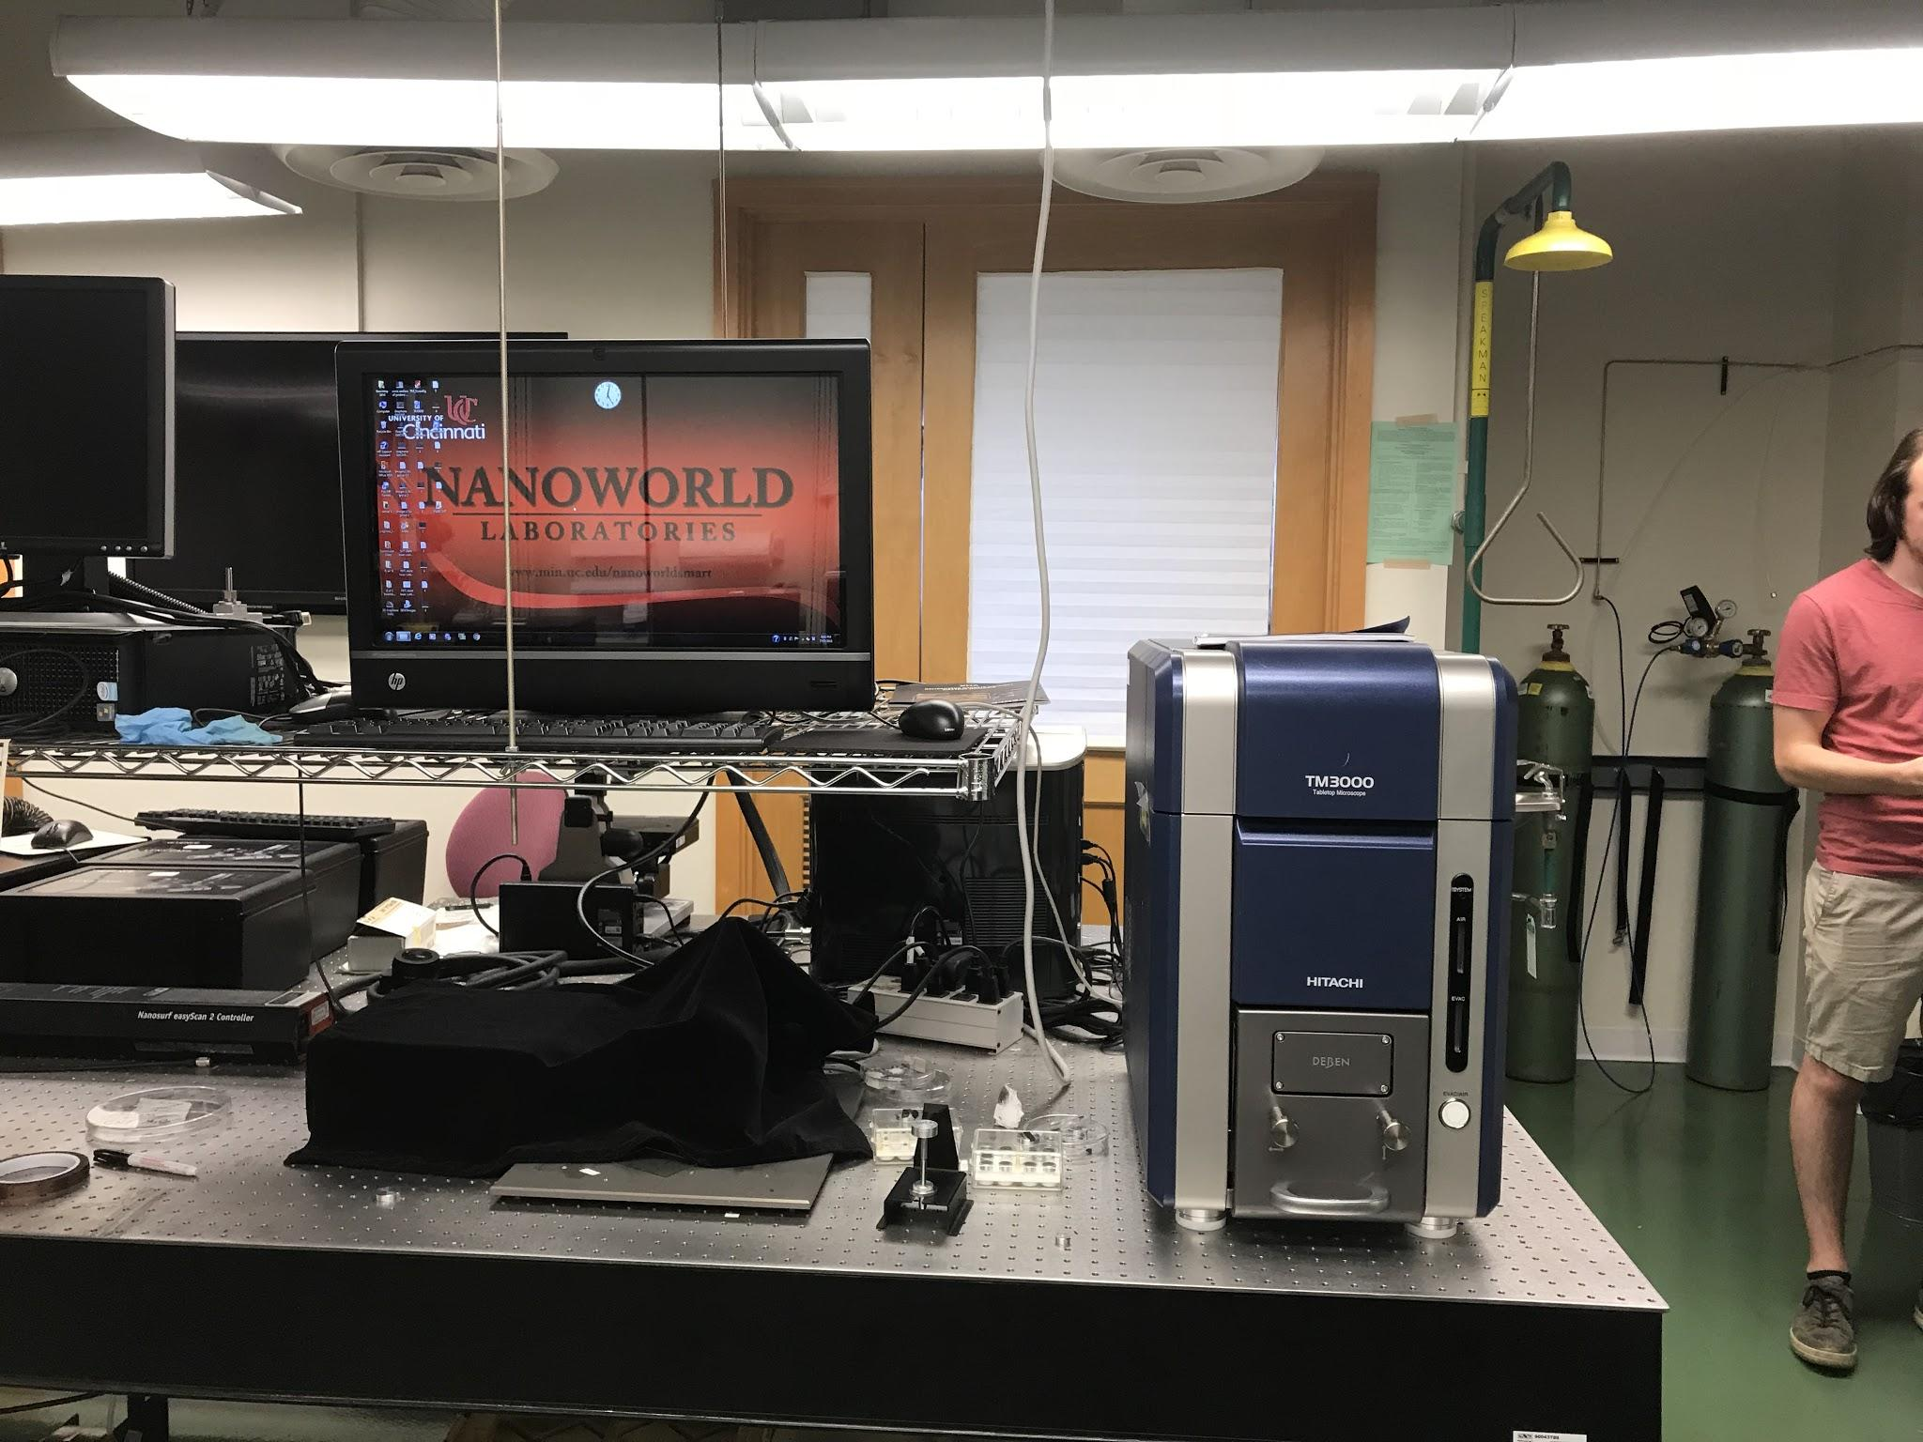
- Scanning Electron Microscope (SEM) Used for Morphology Characterization

- Electrochemical Impedance Spectroscopy (EIS) Used for Resistance Characterization

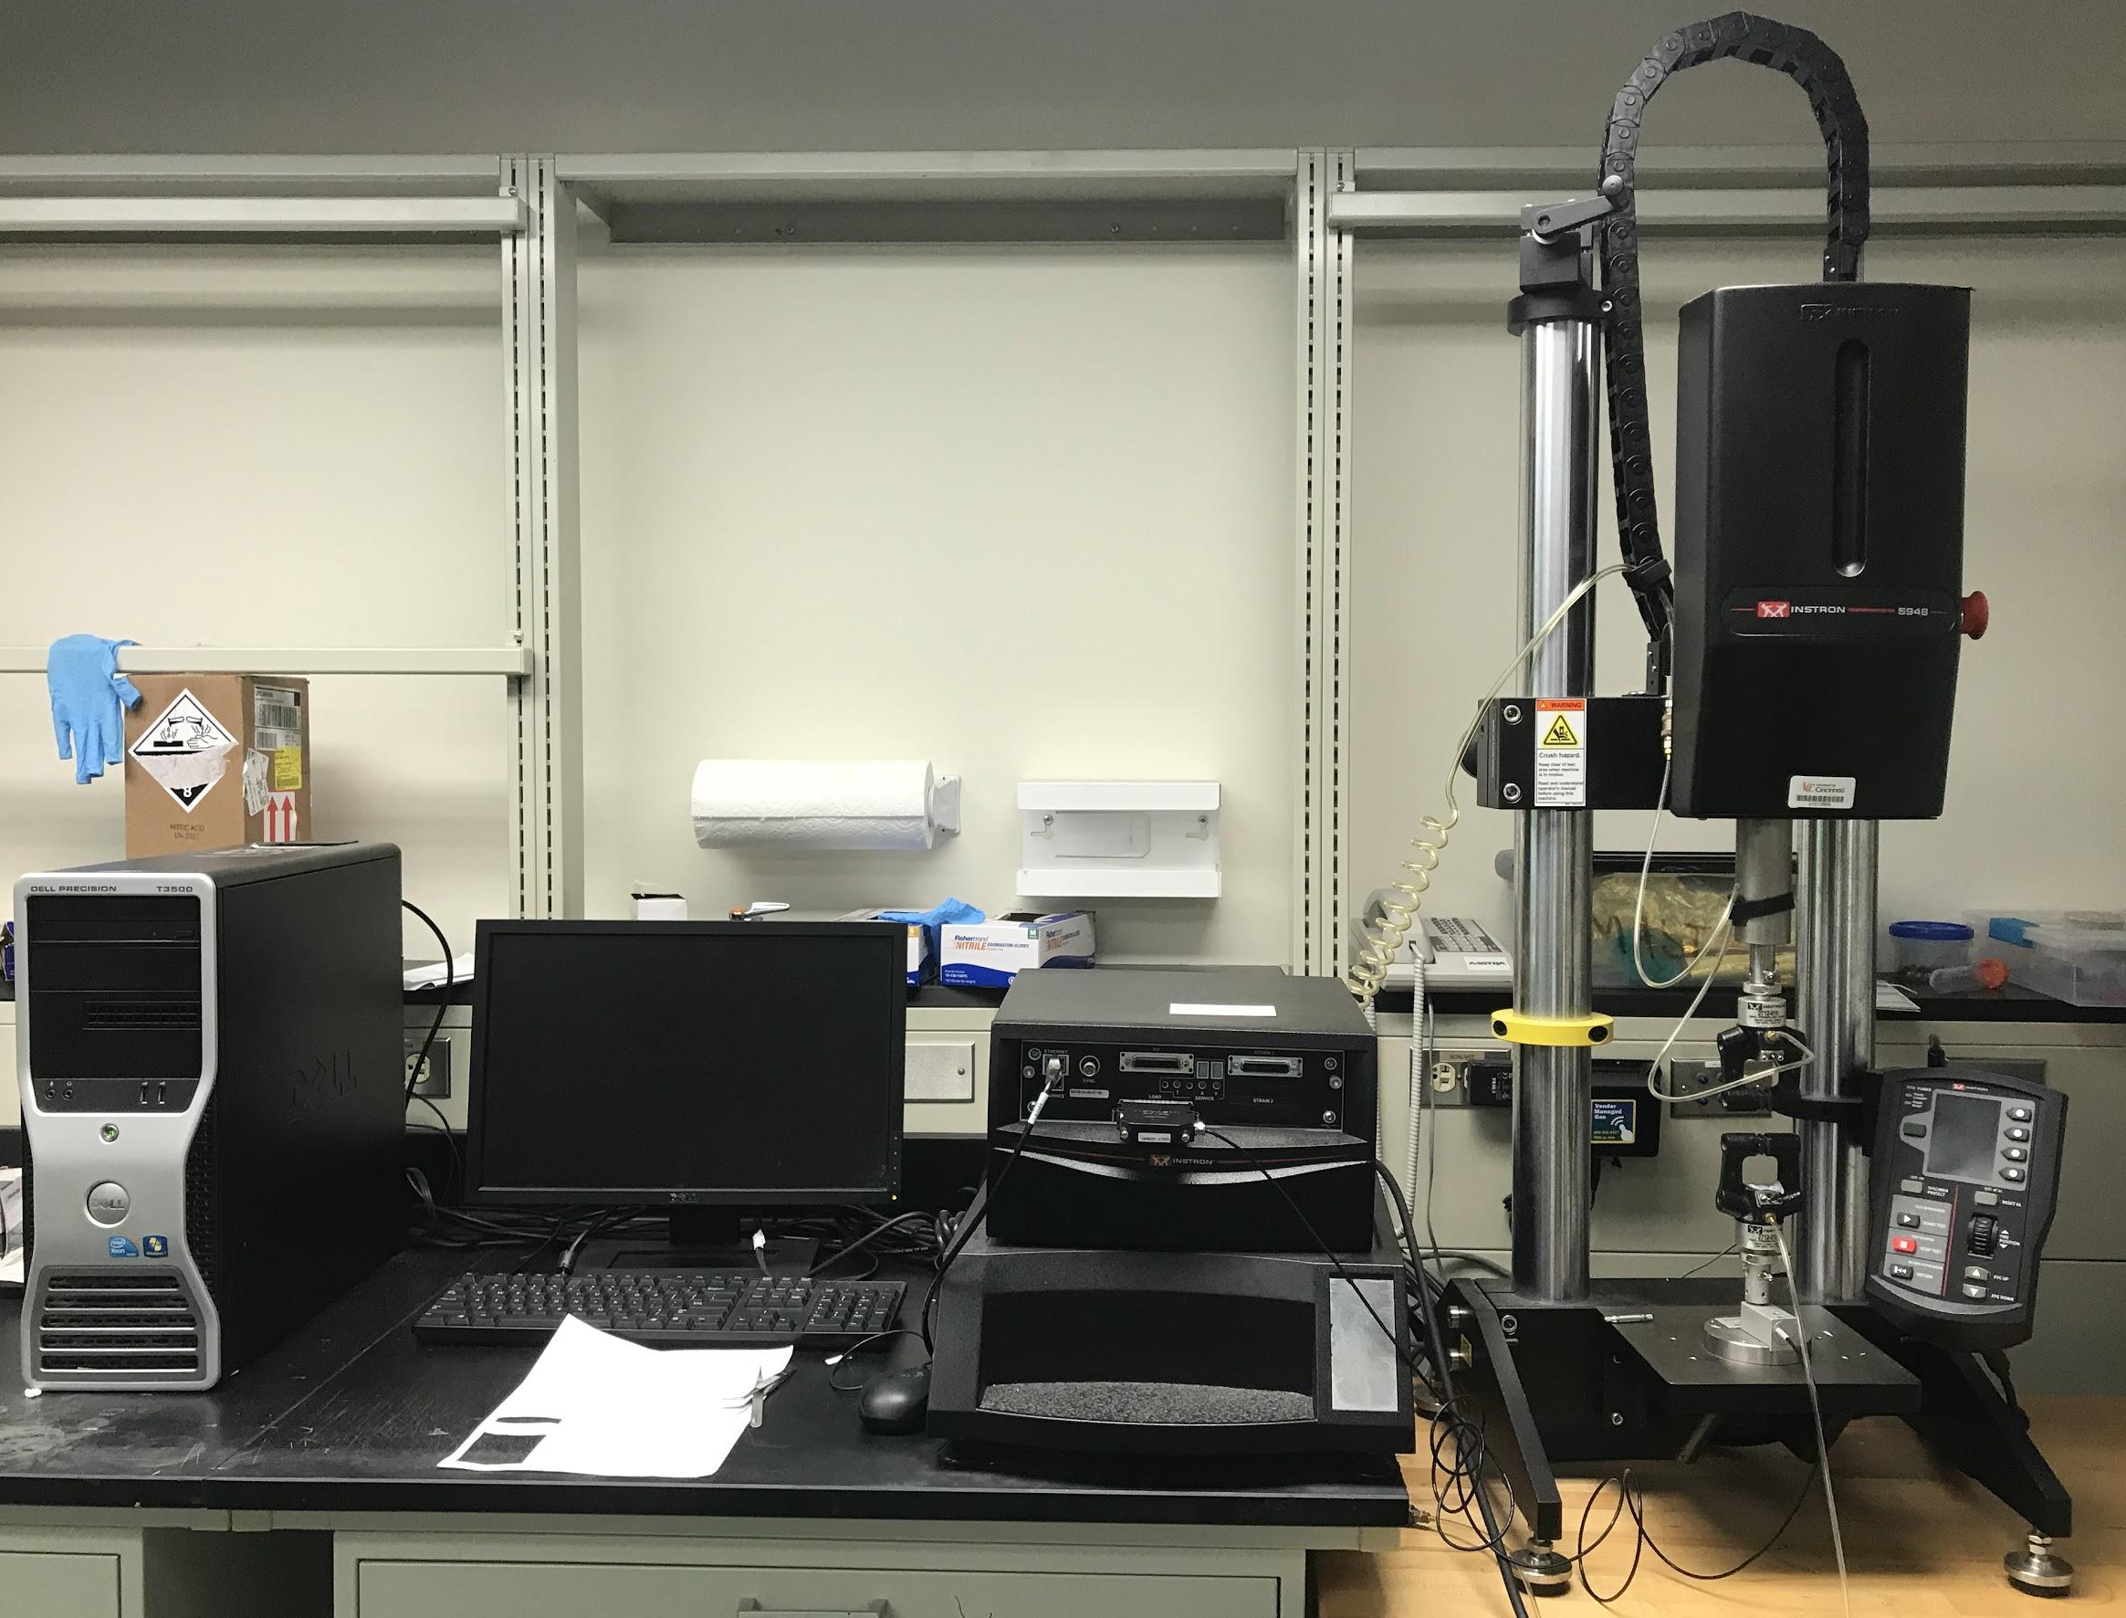
- Instron 5948 Used for Tensile Strength Characterization

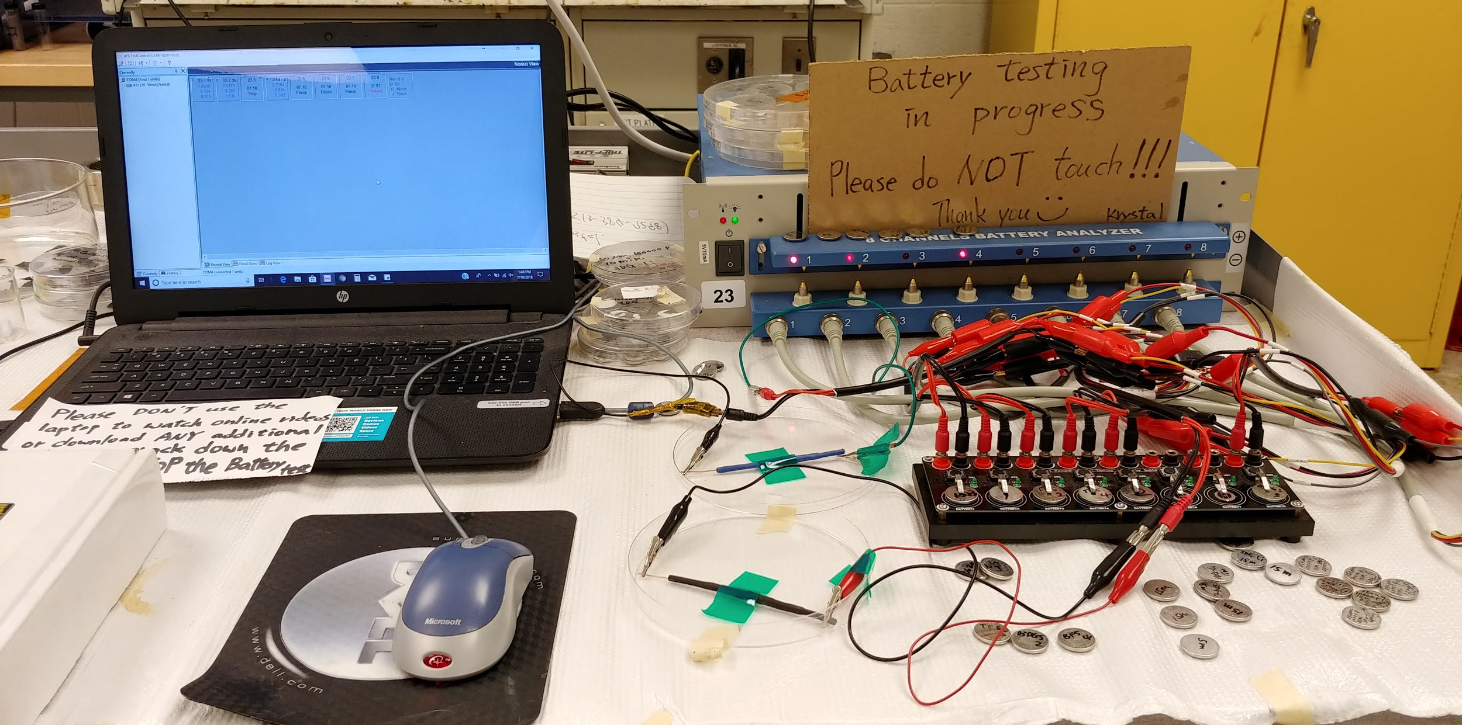
- MTI BST8-MA 8 Channel Battery Analyzer Used for Battery Cycling Testing

14. APPENDIX IV: UNIT TEMPLATE FOR MEGAN STAFFORD

Name: Megan Stafford | Contact Info: 330-606-2402 | Date: 6/19/18

Unit Number and Title: Unit 1 Graphically Representing Optimal Battery Usage

Grade Level: | 11
Subject Area: | Algebra II

Total Estimated Duration of Entire Unit: | 11-13 class periods

Part 1: Designing the Unit
- Unit Academic Standards (Identify which standards: NGSS, OLS and/or CCSS. Cut and paste from NGSS, OLS and/or CCSS and be sure to include letter and/or number identifiers.):
F-IF Interpreting Functions-B:4-6 A-CED Creating Equations-C:7,9
A-CED Creating Equations-A: 1-4 F-LE Linear, Quadratic, and Exponential Models-A:4
F-BF Building Functions-A:1
- Unit Summary
The Big Idea (including global relevance): Optimal Battery Usage
Global relevance: Better understanding the criteria for a battery can assist with improving current batteries especially for renewable energy. A large obstacle with renewable energy stems from the capacity of the batteries.
The (anticipated) Essential Questions: List 3 or more questions your students are likely to generate on their own. (Highlight in yellow the one selected to define the Challenge):
- How can we use math to illustrate the criteria for optimal battery use?
- How can we use math to demonstrate the most efficient use of a battery?
- Can math be used to understand if batteries are efficient at the needed process?
- How do you describe the efficiency of a battery?
- What criteria should be used to decide if one battery is better than another?
- What brand of battery is better than another?
- Unit Context
Justification for Selection of Content– Check all that apply:
✔ Students previously scored poorly on standardized tests, end-of term test or any other test given in the school or district on this content.
☐ Misconceptions regarding this content are prevalent.
✔ Content is suited well for teaching via CBL and EDP pedagogies.
✔ The selected content follows the pacing guide for when this content is scheduled to be taught during the school year. (Unit 1 covers atomic structure because it is taught in October when I should be conducting my first unit.)
☐ Other reason(s) _____________________________________________________________
_____________________________________________________________________________

The Hook: (Describe in a few sentences how you will use a “hook” to introduce the Big Idea in a compelling way that draws students into the topic.)
Play numerous short video clips (games, videos, series) and once the videos hit the climax shut it off and have a battery icon blink as if the computer’s battery died. Playing videos to captures the students’ attention will be key; therefore, I plan to use 3-5 videos. One video will be of a high stakes football or basketball game and this video will be stopped right before a winning shot or just before a running back makes a catch. Another video will be using a well-known movie such as Black Panther and stopping this video at the climax. Additionally, I would like to show a current event video of something actively going around news and social media.

The Challenge and Constraints:

☐ Product or ■ Process (Check one)

Description of Challenge (Either Product or Process is clearly explained below): | List the Constraints Applied
Students will use their MacBooks to analyze battery consumption and graphically interpret the data in order to create a set of criteria for ideal battery consumption. The 3-day consumption of the MacBook batteries will be analyzed using utilities on the MacBooks. | Time (2 full charge cycles)  Students forgetting MacBooks  Testing based upon 3 days of testing  Utilities used for testing: Activity Monitor, Battery Health 1, Battery Health 2, Coconut Battery, and System Information.

Teacher’s Anticipated Guiding Questions (that apply to the Challenge and may change with student input.):
- What is the difference in using Netflix versus Fortnite?
- Which activities use the most energy? Which use the least energy?
- How is battery consumption affected by reducing brightness or reducing sound?
- Does the initial battery life (life cycles) of the MacBook affect battery consumption?
- What is the battery consumption of games versus movies?
- Difference in battery consumption of 2017 versus 2018?
- Computers are outdated ~2-3 years, are batteries outdated as well? (life span of the battery)
- How will graphing information about battery life help me to conserve my usage?
4. EDP: Use the diagram below to help you complete this section.
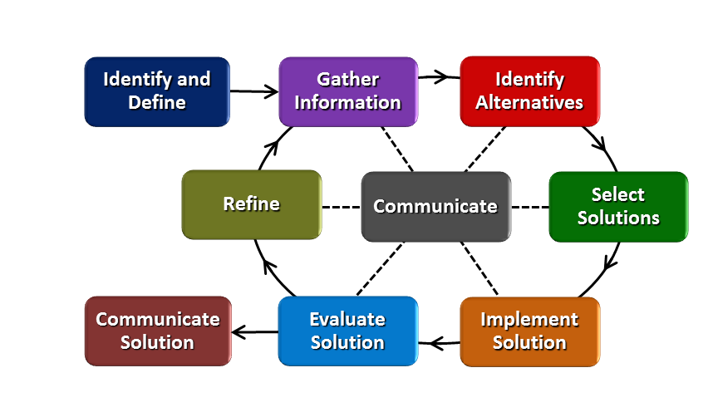
How will students test or implement the solution? What is the evidence that the solution worked? Describe how the iterative process from the EDP applies to your Challenge.
Students will use the Activity Monitor utility on the MacBooks plus utilizing 2 Battery Health apps and system information (available on all MacBooks) to gather information about their MacBook batteries. These functions will provide the following information about the MacBook’s battery: cycle count, condition, amperage, voltage, age of battery, temperature, power usage, and a live graph of power being used. Students will record the initial readings of the above listed criteria. Students will be divided into groups with each group having a different usage they are testing, i.e. movies, games, Netflix, Fortnite and so forth. Based upon their assigned usage, students will record battery data, using the utilities described above, while the MacBook is constantly being used during 3 class periods. Students will then organize their data into tables and graphically analyze the battery usage. Using this information students will create criteria for ideal battery consumption. The criteria for each group can and will likely differ based upon how their MacBooks are being used. Their criteria will be supported by the data they gathered during testing. Once the students have created their criteria they will be given 3 days to retest their battery under modified criteria, which they choose, while still testing under the same usage (movies, games, Netflix, Fortnite and so forth). Students then can compare the 2 different testing conditions using tables and graphs once again. The comparison between the 2 testing conditions will serve to further support or demand refining the criteria the students created for ideal battery consumption.
The iterative process from the EDP is weaved throughout this challenge as students will gather information through the guiding questions and then continue gathering information from the Activity Monitor, Battery Health apps, and System Information. Additional information will be gathered during the first testing phase when students gain baseline information about battery consumption based upon how their MacBooks are being used. Once students have this information they will be able to identify alternatives on how to more efficiently use their batteries for maximum battery life. These alternatives will be compiled into a set of criteria. Using this criteria students will arrange for different modifications, such as reducing brightness or window size of the game, that follow their criteria for better battery consumptions. These modifications will be implemented and evaluated. Once testing with the modifications is complete students can evaluate the two sets of results and refine (time permitted). If time is the same constraint students can discuss and report how they would refine.
How will students present or defend the solution? Describe if any formal training or resource guides will be provided to the students for best practices (e.g., poster, flyer, video, advertisement, etc.) used to present work.
Students will present their criteria and findings to their class via a presentation (PowerPoint or KeyNote). A rubric for the presentation will be provided to the students. This rubric will outline the required material which must be present within their presentations. The rubric will also outline requirements for the length of the presentation and ensuring equal participation from all members.

What academic content is being taught through this Challenge?
A-CED Creating Equations-A: 1-4----Students will learn to create equations in one variable to solve problems, create equations in 2 or more variables to represent relationships between quantities, represent constraints in equations, and rearrange formulas to highlight a quantity of interest. This will be achieved through Physics equations applying the amperage and voltage students obtain from their MacBooks. Students will also have the opportunity to create an equation or inequality which integrates cycle life.
F-IF Interpreting Functions-B:4-6--- Students will interpret functions including interpreting key features of graphs and tables, relate the domain of a function to its graph and describe the relationship, and calculate and interpret the average rate of change of a function. This content will be taught and practiced once students have results to compile and interpret.

F-IF Interpreting Functions-C:7,9---- Students will analyze functions using different representations by graphing functions expressed symbolically and showing key features of the graph and students will compare properties of 2 functions each represented in a different way (algebraically, graphically, numerically in tables, or by verbal description). This content will be taught and practiced as students analyze the functions they created with cycle life in addition to analyzing the amperage and voltage equations in combination with analyzing the graphs they created using their data from the testing.

F-BF Building Functions-A:1----Students will write a function to describe a relationship between 2 quantities. Students will be able to do this when they write a function to incorporate cycle life after they have practiced using the physics equations involving amperage and voltage.

F-LE Linear, Quadratic, and Exponential Models-A:4---Students will construct and compare different models of graphs when they have compiled their data, arranged into graphs, and compared the 2 different testing rounds.

Assessment and EDP:
Using the diagram above, identify any places in the EDP where assessments should take place, as it applies to your Challenge. Describe below what kinds of assessment are most appropriate.

What EDP Processes are ideal for conducting an Assessment? (List ones that apply.) | List the type of Assessment (Rubric, Diagram, Checklist, Model, Q/A etc.) Check box to indicate whether it is formative or summative.
__Identify & Define_____  _Gather Information____  __Select Solution_____  _Evaluate Solution_____ | ____ Pre-test ____________________ ✔ formative ☐ summative  __Q/A from one day of testing to the next ✔ formative ☐ summative  Communicate Optimal Battery Criteria (Presentation) Rubric ☐ formative ✔ summative  __Post-test_______________________ ✔ formative ☐ summative
Check below which characteristic(s) of this Challenge will be incorporated in its implementation using EDP. (Check all that apply.)
✔ Has clear constraints that limit the solutions
✔ Will produce than one possible solution that works
✔ Includes the ability to refine or optimize solutions
✔ Assesses science or math content
✔ Includes Math applications
✔ Involves use of graphs
✔ Requires analysis of data
✔ Includes student led communication of findings

5. ACS (Real world applications; career connections; societal impact):
Place an X on the continuum to indicate where this Challenge belongs in the context of real world applications:
Abstract or Loosely Applies to the Real World | |--------------------------------------|--------------------X------------------| | Strongly Applies to the Real World

Provide a brief rationale for where you placed the X: The students can apply this unit to the real world as the majority carry cell phones and are constantly charging their phones throughout the school day, combatting the dead battery. Students can also apply this to the real world as every student has a MacBook that is expected to be fully charged at the beginning of the school day and last all day if utilized properly.
What activities in this Unit apply to real world context? Activity # 2 applies to societal impact by analyzing battery consumption and allowing students to define the criteria for ideal battery consumption. This activity applies to society as much of our society is dependent upon batteries and their performance.

Place an X on the continuum to indicate where this Challenge belongs in the context of societal impact:
Shows Little or No Societal Impact | |-------------------------------------|------X---------------------------------| | Strongly Shows Societal Impact

Provide a brief rationale for where you placed the X: With much of our society dependent upon batteries and how they perform students can see how creating criteria for ideal battery consumption goes beyond playing movies or Fortnite all day on their MacBooks. Instead this criteria they create can be applied to ensure batteries are consumed in the most ideal way to allow for that piece of technology to be used for a longer period of time and used to its maximum capacity. This can be related to renewable energy source.

What activities in this Unit apply to societal impact? Activity # 2 applies to societal impact by analyzing battery consumption and allowing students to define the criteria for ideal battery consumption. This activity applies to society as much of our society is dependent upon batteries and their performance.

Careers: What careers will you introduce (and how) to the students that are related to the Challenge? (Examples: career research assignment, guest speakers, fieldtrips, Skype with a professional, etc.)
Introduce Engineering careers and have students introduce and discuss 2 examples of careers during their presentations when they Communicate Solutions.

6. Misconceptions:
A common misconception might be the necessary, school-related energy usage of their MacBooks versus wasted usage. The wasted usage is being directly represented during the activities as students observe their MacBooks batteries while watching movies, Netflix, playing games, etc.
7. Unit Lessons and Activities: (Provide a tentative timeline with a breakdown for Lessons 1 and 2. Provide the Lesson #’s and Activity #’s for when the Challenge Based Learning (CBL) and Engineering Design Process (EDP) are embedded in the unit.)
Unit 1: Criteria for Optimal Battery Usage
Lesson 1: Creating Equations in one variable and rearranging equations to highlight a desired variable. Students will be given an understanding of how their MacBooks are used and the ideal cycle life of their MacBook batteries. Students will practice rearranging equations while using the information supplied in the MacBook applications, such as amperage or voltage. (2 days)
Activity 1: Introduction of Big Idea, Hook, Generating Essential Questions, Challenge, Pre-test, and Guiding Questions. (2 days)
Activity 2: Gathering of information about the MacBooks’ batteries. This activity will specifically involve utilizing the applications on the MacBooks: System Information, Activity Monitor, Battery Health 1 & 2, and Coconut Battery. (1 day)
Lesson 2: Interpreting and creating equations using tables and graphs. This will be taught using the data students have gathered from first round of testing. This knowledge will be reapplied after the second round of testing and then comparisons will be made to assist the students in refining their optimal battery usage criteria.
Activity 3: Testing round 1 of MacBook usage. During this round of testing students will be working in their assigned groups and will begin monitoring and recording the data about their MacBooks’ batteries while constantly playing the determined usage. The above described applications will be used to obtain data. (3 days)
Activity 4: Testing round 2 of MacBook usage. During this round of testing students have designated criteria to assist with optimal battery usage (reducing brightness, reducing sound, decreasing window size, etc.) and will test their MacBook batteries with the same usage but applying these criteria. The same applications will be used as described above. Once students have obtained this data they will interpret their data and refine their optimal battery usage criteria. (3 days)
CBL: Lesson, 1, Activity 1 & Lesson 2, Activity 4
EDP: Lesson 2, Activity 4
8. Keywords:
Battery, battery consumption, battery usage, MacBook, battery cycle life, battery voltage, battery amperage, MacBook battery durability

9. Additional Resources:

10. Pre-Unit and Post-Unit Assessment Instruments:
Will conduct pre-test and post- test online using MacBooks and Schoology platform.

11. Poster | 12. Video (Link here.)

If you are a science teacher, check the boxes below that apply:
Next Generation Science Standards (NGSS)
Science and Engineering Practices (Check all that apply) | Crosscutting Concepts (Check all that apply)
✔ Asking questions (for science) and defining problems (for engineering) | ☐ Patterns
☐ Developing and using models | ☐ Cause and effect
✔ Planning and carrying out investigations | ☐ Scale, proportion, and quantity
☐ Analyzing and interpreting data | ☐ Systems and system models
✔ Using mathematics and computational thinking | ☐ Energy and matter: Flows, cycles, and conservation
☐ Constructing explanations (for science) and designing solutions (for engineering) | ☐ Structure and function.
☐ Engaging in argument from evidence | ☐ Stability and change.
✔ Obtaining, evaluating, and communicating information

If you are a science teacher, check the boxes below that apply:
Ohio’s Learning Standards for Science (OLS)
Expectations for Learning - Cognitive Demands (Check all that apply)
☐ Designing Technological/Engineering Solutions Using Science concepts (T)
☐ Demonstrating Science Knowledge (D)
☐ Interpreting and Communicating Science Concepts (C)
☐ Recalling Accurate Science (R)

If you are a math teacher, check the boxes below that apply:
Ohio’s Learning Standards for Math (OLS) or
Common Core State Standards -- Mathematics (CCSS)
Standards for Mathematical Practice (Check all that apply)
✔ Make sense of problems and persevere in solving them | ✔ Use appropriate tools strategically
✔ Reason abstractly and quantitatively | ✔ Attend to precision
✔ Construct viable arguments and critique the reasoning of others | ☐ Look for and make use of structure
✔ Model with mathematics | ✔ Look for and express regularity in repeated reasoning

Name: Megan Stafford | Contact Info: 330-606-2402 | Date: 07/02/2018

Lesson Title : Rearranging and Creating Equations | Unit #: 1 | Lesson #: 1 | Activity #: 1
Activity Title: Battery Usage Introduction

Estimated Lesson Duration: | 3 days
Estimated Activity Duration: | 1 day

Setting: | Classroom with MacBooks

Activity Objectives:
We will create and rearrange equations to solve for a variable and understand relationships.
I will be able to create and rearrange equations to solve problems.

We will work towards an essential question about MacBook battery usage.
I will be able to generate essential questions.
(can be measured/recorded for a formative grade by having students submit questions on Schoology or PollEverywhere)

Activity Guiding Questions:
- How can equations be rearranged when only variables are present?
- What can an equation define about a relationship between the variables?
- If not all classes use MacBooks every day, then is conserving the MacBook battery worthwhile?
- What applications are permitted during testing?
  - (students will be introduced to the application during activity 2)
- Are we only testing MacBooks?
- How will graphing information about battery life help me to conserve my usage?
- Does the initial battery life (life cycles) of the MacBook affect battery consumption?
  - Students receive MacBooks at the beginning of the year and it is very likely their MacBooks were used the year before as MacBooks are updated in phases.
- What is the battery consumption of games versus movies?
- Can students use any movie website during testing? What movies are permitted? What games are permitted?

Next Generation Science Standards (NGSS)
Science and Engineering Practices (Check all that apply) | Crosscutting Concepts (Check all that apply)
✔ Asking questions (for science) and defining problems (for engineering) | ☐ Patterns
☐ Developing and using models | ☐ Cause and effect
☐ Planning and carrying out investigations | ☐ Scale, proportion, and quantity
☐ Analyzing and interpreting data | ☐ Systems and system models
✔ Using mathematics and computational thinking | ☐ Energy and matter: Flows, cycles, and conservation
☐ Constructing explanations (for science) and designing solutions (for engineering) | ☐ Structure and function.
☐ Engaging in argument from evidence | ☐ Stability and change.
☐ Obtaining, evaluating, and communicating information

Ohio’s Learning Standards for Science (OLS)
Expectations for Learning - Cognitive Demands (Check all that apply)
☐ Designing Technological/Engineering Solutions Using Science concepts (T)
☐ Demonstrating Science Knowledge (D)
☐ Interpreting and Communicating Science Concepts (C)
☐ Recalling Accurate Science (R)

Ohio’s Learning Standards for Math (OLS) and/or
Common Core State Standards -- Mathematics (CCSS)
Standards for Mathematical Practice (Check all that apply)
☐ Make sense of problems and persevere in solving them | ✔ Use appropriate tools strategically
✔ Reason abstractly and quantitatively | ☐ Attend to precision
☐ Construct viable arguments and critique the reasoning of others | ☐ Look for and make use of structure
✔ Model with mathematics | ✔ Look for and express regularity in repeated reasoning

Unit Academic Standards (NGSS, OLS and/or CCSS):
A-CED Creating Equations-A: 1-4----Students will learn to create equations in one variable to solve problems, create equations in 2 or more variables to represent relationships between quantities, represent constraints in equations, and rearrange formulas to highlight a quantity of interest.

Materials: (Link Handouts, Power Points, Resources, Websites, Supplies)
- Pre-test: see pre & post test document
- Hook videos: to be created closer to unit implementation so videos are from current events (recent World Cup, football games, current world events, etc.)

Teacher Advance Preparation:
Create Hook videos, ensure links/videos work with school WiFi.

Activity Procedures:
Activity 1: Day 1
- Introduction of Big Idea. This unit will be implemented after teaching a statistics unit and after reviewing 1 and multistep equations. Therefore, I will move into this unit about interpreting and creating functions by reviewing a few problems with a brief, interactive activity, such as board races or use individual dry erase and let them earn snacks or extra credit points. I will also have the students possible show me what they know about slope trends from geometry and algebra 1.
- Content being taught: A-CED Creating Equations-A: 1-4----Students will learn to create equations in one variable to solve problems, create equations in 2 or more variables to represent relationships between quantities, represent constraints in equations, and rearrange formulas to highlight a quantity of interest. After introducing the Big Idea students will be refreshed with how to solve equations. Therefore, this standard will be taught through Physics equations applying the current charge data students obtain from their MacBooks. Students will also have the opportunity to create an equation or inequality, which integrates cycle life, relating the theoretical capacity with the actual capacity used. These numbers will be different for every MacBook which allows students to individually master this standard.
Activity 1: Day 2
- Hook- Show numerous videos as if the MacBook battery had died. These videos will be less than 30 seconds each and will portray a climax of a sporting event (World Cup, NBA Finals, Superbowl…), a climax of a movie (will choose a popular movie such as Black Panther), and a climax from a current event. The goal from this hook is to have the students become interested in the fact that they don’t get to finish watching the video because the battery would have died.
- Generating Essential Questions- Will prompt students and create a list of essential questions. This will be done using Schoology or PollEverywhere in order to record participation and to have a record of submitted questions. Using one of those two platforms will also allow me to show the students the questions being submitted. Teacher will then choose highlight similar essential questions and communicate the essential question which will be investigated.
- Challenge- After highlighting similar essential questions, teacher will begin discussion about possible challenges that could be performed to better understand the MacBook batteries and how to use the batteries most efficiently. These challenge ideas can be brainstormed using think-pair-share. The teacher will then record their ideas and introduce the challenge of creating a set of criteria for optimal use of their MacBook batteries. Discuss how this criterion can go beyond their MacBooks and go beyond the classroom.
- Pre-test- Administer pre-test via Schoology. If student does not have MacBook to take the pre-test on Schoology, I will supply a paper copy and remind student MacBook must be brought daily.
- Guiding Questions- Allow students to self-generate guiding questions for information they want and/or need for the challenge. These questions can be written down on an anchor chart or a shared Google document to allow for students to see them whole group.
Formative Assessments: Link the items in the Activities that will be used as formative assessments.

Generating Essential Questions. Generating the Guiding Questions.
Pre-test: See pre & post test document
Summative Assessments: These are optional; there may be summative assessments at the end of a set of Activities or only at the end of the entire Unit.

None
Differentiation: Describe how you modified parts of the Lesson to support the needs of different learners.
Refer to Activity Template for details.

Pre-test will be offered via Schoology platform but will also be offered as paper copies for the needs of the different learns. This pre-test will be also be offered to the different learning students to be taken in the environment with the Special-Education co-lab teacher.

Name: Megan Stafford | Contact Info: 330-606-2402 | Date: 07/02/2018

Lesson Title : Rearranging and Creating Equations | Unit #: 1 | Lesson #: 1 | Activity #: 2
Activity Title: Gathering MacBook Information

Estimated Lesson Duration: | 3 days
Estimated Activity Duration: | 1 day

Setting: | Classroom with MacBooks

Activity Objectives:
We will introduce MacBook applications to understand the battery life and usage of our MacBooks.
I will be able to analyze the battery charge and usage of my MacBook battery.
(this can be measured/recorded by students being able to create a Google Spreadsheet and write in their MacBook’s individual theoretical, initial capacity. These Google Spreadsheets will be shared with the teacher to allow for formative checks.)

Activity Guiding Questions:
- How does the age of the MacBook affect the number of cycles?
- How often is the real time data refreshing?
- Does the data from the applications get applied to equations?
- Can other applications be used besides System Information, Battery Health, Activity Monitor, and Coconut Battery?
- To create an equation, which information from the applications is related?
- What does mAh stand for?

Next Generation Science Standards (NGSS)
Science and Engineering Practices (Check all that apply) | Crosscutting Concepts (Check all that apply)
✔ Asking questions (for science) and defining problems (for engineering) | ☐ Patterns
☐ Developing and using models | ☐ Cause and effect
☐ Planning and carrying out investigations | ☐ Scale, proportion, and quantity
✔ Analyzing and interpreting data | ☐ Systems and system models
✔ Using mathematics and computational thinking | ☐ Energy and matter: Flows, cycles, and conservation
☐ Constructing explanations (for science) and designing solutions (for engineering) | ☐ Structure and function.
☐ Engaging in argument from evidence | ✔ Stability and change.
✔ Obtaining, evaluating, and communicating information

Ohio’s Learning Standards for Science (OLS)
Expectations for Learning - Cognitive Demands (Check all that apply)
☐ Designing Technological/Engineering Solutions Using Science concepts (T)
☐ Demonstrating Science Knowledge (D)
☐ Interpreting and Communicating Science Concepts (C)
☐ Recalling Accurate Science (R)

Ohio’s Learning Standards for Math (OLS) and/or
Common Core State Standards -- Mathematics (CCSS)
Standards for Mathematical Practice (Check all that apply)
☐ Make sense of problems and persevere in solving them | ✔ Use appropriate tools strategically
✔ Reason abstractly and quantitatively | ☐ Attend to precision
☐ Construct viable arguments and critique the reasoning of others | ☐ Look for and make use of structure
✔ Model with mathematics | ✔ Look for and express regularity in repeated reasoning

Unit Academic Standards (NGSS, OLS and/or CCSS):
A-CED Creating Equations-A: 1-4----Students will learn to create equations in one variable to solve problems, create equations in 2 or more variables to represent relationships between quantities, represent constraints in equations, and rearrange formulas to highlight a quantity of interest.

F-BF Building Functions-A:1----Students will write a function to describe a relationship between 2 quantities.

Materials: (Link Handouts, Power Points, Resources, Websites, Supplies)
PowerPoint: Created to mirror handout to assist with understanding of applications
First slide of PowerPoint will be list assigned groups. Groups will then assign roles.

Handout: To be used for entirety of Unit.
Data will be recorded into Google Sheets. Handout will show instructions to ease the use of Google Sheets and clearly outline data to be collected.

Participation rubric: to be completed by reflector (see roles below in activity procedures) and turned in daily.

Resources:
Applications to be used: System information and Activity Monitor
Applications to be downloaded: Battery Health 1 & Battery Health 2
Applications to be used via internet: Coconut Battery, Google Sheets

Supplies: School supplied MacBooks (students are assigned MacBooks at the start of the school year)
Will use Apple TV to screen mirror teacher MacBook and mirror applications as students become accustomed to information supplied in these applications.

Teacher Advance Preparation:
- Based upon pre-test results from question #1, group students accordingly based upon the use of their MacBooks.
- Ensure applications can be downloaded using the school WiFi.
- Ensure students are able to access System Information and Activity Monitor on their MacBooks.
- Create/modify PowerPoint as described above.
- Copy handout and participation rubric. Modify as needed.
-Participation rubric to be available and submitted online

Activity Procedures:
Gathering of information about the MacBooks’ batteries. This activity will specifically involve utilizing the applications on the MacBooks: System Information, Activity Monitor, Battery Health 1 & 2, and Coconut Battery.

- PowerPoint is projected showing assigned groups.
- Handouts are distributed.
- Each group assigns roles:
- Manager: This student will manage the group by helping to ensure the group stays on task and ensures there is room for everyone in the conversation.
- Recorder: This student will record information into the Google Sheets Spreadsheet.
- Runner: This student will communicate directly with the teacher. The runner will also record questions, concerns, and misconceptions the group may have that need to be brought to the teacher’s attention.
- Reflector: This student will keep a record of those who are in the group, and the roles that each student will play in the group. The reflector will also complete the participation rubric to give to teacher at the end of each day. This rubric will likely be available via paper copy or via Google Forms. (Google Forms will be the preferred submission)
Participation Rubric
- Time keeper: This student will prompt the recorder to record data at designated time intervals of 5 minutes. I will recommend the time keeper uses a phone for proper record keeping. The time keeper will work with the manager to stay on task given the class time.
- Introduction to System Information and Activity Monitor. Each student follows along on their MacBooks as teacher screen mirrors.
- Downloading of Battery Health applications. Students follow along as teacher screen mirrors.
- Recorder of each group, using Google Sheets, records the initial information about the group’s MacBooks (cycles and age). Google spreadsheet is then shared with teacher.
- Students use information from applications and knowledge from previous day to substitute actual data into equations and solve for a variable.
Formative Assessments: Link the items in the Activities that will be used as formative assessments.

Once each group has created their spreadsheet on Google Sheets, the groups will share with teacher. Successful creation and sharing of spreadsheet = formative completion grade.

Participation rubric
Summative Assessments: These are optional; there may be summative assessments at the end of a set of Activities or only at the end of the entire Unit.

None
Differentiation: Describe how you modified parts of the Lesson to support the needs of different learners.
Refer to Activity Template for details.

- Create longer handout containing more screen shots. (visual learners)
- Create a video to post onto Schoology will audio. Handout to act as guided notes during video. (auditory learners)

Name: Megan Stafford | Contact Info: 330-606-2402 | Date: 7/02/2018

Lesson Title : Interpreting and creating equations using tables and graphs | Unit #: 1 | Lesson #: 2 | Activity #: 3
Activity Title: MacBook Testing Round 1

Estimated Lesson Duration: | 6 days
Estimated Activity Duration: | 3 days

Setting: | Classroom with MacBooks

Activity Objectives:
We will begin testing our MacBook batteries using System Information, Activity Monitor, and Battery Health.
I will participate in my group to collect data in Google Sheets and fulfill my assigned group role.

We will continue testing our MacBook batteries.
I will participate in my group to collect data in Google Sheets and fulfill my assigned group role.

We will finish our 1st round of MacBook battery testing.
I will interpret the data collected from round 1 and project adjustments for round 2 of testing.

(this can be measured/recorded by students being able to create a Google Spreadsheet and write in their MacBook’s individual theoretical, initial capacity. These Google Spreadsheets will be shared with the teacher to allow for formative checks.)

Activity Guiding Questions:
- What if the MacBooks being tested finish (batteries die) at different times?
- Does every MacBook in the group need to watch the same movie? Play the same game?
- Should the MacBooks be set to the same volume level and same brightness?
- How many data points should be collected to observe a trend?
- Will 3 days of testing provide accurate data? Does the same movie or game need played on the subsequent days to accurately observe a trend?

Next Generation Science Standards (NGSS)
Science and Engineering Practices (Check all that apply) | Crosscutting Concepts (Check all that apply)
✔ Asking questions (for science) and defining problems (for engineering) | ✔ Patterns
☐ Developing and using models | ☐ Cause and effect
☐ Planning and carrying out investigations | ☐ Scale, proportion, and quantity
✔ Analyzing and interpreting data | ☐ Systems and system models
✔ Using mathematics and computational thinking | ☐ Energy and matter: Flows, cycles, and conservation
☐ Constructing explanations (for science) and designing solutions (for engineering) | ☐ Structure and function.
☐ Engaging in argument from evidence | ✔ Stability and change.
✔ Obtaining, evaluating, and communicating information

Ohio’s Learning Standards for Science (OLS)
Expectations for Learning - Cognitive Demands (Check all that apply)
☐ Designing Technological/Engineering Solutions Using Science concepts (T)
☐ Demonstrating Science Knowledge (D)
☐ Interpreting and Communicating Science Concepts (C)
☐ Recalling Accurate Science (R)

Ohio’s Learning Standards for Math (OLS) and/or
Common Core State Standards -- Mathematics (CCSS)
Standards for Mathematical Practice (Check all that apply)
☐ Make sense of problems and persevere in solving them | ✔ Use appropriate tools strategically
✔ Reason abstractly and quantitatively | ☐ Attend to precision
☐ Construct viable arguments and critique the reasoning of others | ☐ Look for and make use of structure
✔ Model with mathematics | ✔ Look for and express regularity in repeated reasoning

Unit Academic Standards (NGSS, OLS and/or CCSS):
F-IF Interpreting Functions-B:4-6--- Students will interpret functions including interpreting key features of graphs and tables, relate the domain of a function to its graph and describe the relationship, and calculate and interpret the average rate of change of a function. This content will be taught and practiced once students have results to compile and interpret.

F-IF Interpreting Functions-C:7,9---- Students will analyze functions using different representations by graphing functions expressed symbolically and showing key features of the graph and students will compare properties of 2 functions each represented in a different way (algebraically, graphically, numerically in tables, or by verbal description). This content will be taught and practiced as students analyze the functions they created with cycle life in addition to analyzing the amperage and voltage equations in combination with analyzing the graphs they created using their data from the testing.

Materials: (Link Handouts, Power Points, Resources, Websites, Supplies)
PowerPoint: Created to mirror handout to assist with understanding of applications
Remind students of group roles to ensure full participation.
PowerPoint will also provide Google Sheets hints and additional instructions (as needed).

Handout: To be used for entirety of Unit.
Data will be recorded into Google Sheets. Handout will show instructions to ease the use of Google Sheets and clearly outline data to be collected.

Participation rubric: to be completed by reflector (see roles below in activity procedures) and turned in daily.

Resources:
Applications to be used: System information and Activity Monitor
Applications to be downloaded: Battery Health 1 & Battery Health 2
Applications to be used via internet: Coconut Battery, Google Sheets

Supplies: School supplied MacBooks (students are assigned MacBooks at the start of the school year)
Will use Apple TV to screen mirror teacher MacBook and mirror applications as students become accustomed to information supplied in these applications.

Teacher Advance Preparation:
- Create/modify PowerPoint as described above.
- Check all groups have shared their Google Spreadsheet with teacher. Identify groups that have not and advise of this before beginning round 1 of testing.

Activity Procedures:
Testing round 1 of MacBook usage. During this round of testing students will be working in their assigned groups and will begin monitoring and recording the data about their MacBooks’ batteries while constantly playing the determined usage. The above described applications will be used to obtain data.

Day 1:
- Based upon the group’s assigned MacBook usage (movie, game, Netflix…) the students will begin monitoring and recording the data about their groups’ MacBooks’ batteries while using the applications previously introduced.
- Teacher will remind students of group roles by using PowerPoint to display each role’s duties.
- Direct Instruction: Teacher will answer any questions about Round 1 of testing or about how to record in Google Sheets This will be completed using Apple TV screen mirroring to display Google Sheets and actively show students in real time how to fix any issues or demonstrate how to create graphs and insert trend lines and so forth. This can also be completed answering questions group by group.
- Circulate throughout testing to ensure students are properly recording data as their MacBook batteries are being used and depleted.
Day 2:
- Teacher will remind students of group roles by using PowerPoint to display each role’s duties.
- Direct Instruction: Teacher will answer any questions about Round 1 of testing or about how to record in Google Sheets This will be completed using Apple TV screen mirroring to display Google Sheets and actively show students in real time how to fix any issues or demonstrate how to create graphs and insert trend lines and so forth. This can also be completed answering questions group by group.
- Teacher will prompt students to begin thinking about their data as they collect day 2 data. During this prompting the teacher will ensure students are following the handout for decreasing confusion about using Google Sheets. Additionally, the teacher can spark conversations as students begin to see trends in their data.
- Teacher will answer any questions that arise while circulating. These questions should be communicated to the teacher from the student designated as the runner, but while circulating other students may have questions as well.
- Begin testing. Same instruction as Day 1. See #1 above.
Day 3:
- Remind of group roles. All roles can begin assisting, in their own capacity, with interpreting and analyzing data as described per handout.
- Direct instruction: Troubleshoot prior to beginning testing on Day 3.
- Teacher will prompt students to begin thinking about their data as they collect day 3 data. During this prompting the teacher will ensure students are following the handout for decreasing confusion about using Google Sheets. Additionally, the teacher can spark conversations as students begin to see trends in their data. Their handout will outline how to begin plotting the data points collected during the previous 2 days of testing.
- Teacher will answer any questions that arise while circulating. These questions should be communicated to the teacher from the student designated as the runner, but while circulating other students may have questions as well.
- Begin testing. Same instruction as Day 1. See #1 from Day 1 above.
- After testing has completed, students will be prompted by teacher and handout to review data, interpret results using Google Sheets, collaborate with group members and brainstorm ways to improve the batteries’ performance for the second round of testing, such as decreasing audio volume or reducing brightness. These ideas/criteria for improved battery performance will be recorded into Google Sheets.
Formative Assessments: Link the items in the Activities that will be used as formative assessments.

Participation Rubric

Formative points for completion of round 1 of testing (3 days). This will be graded for completion as teacher will have access to each group’s Google Spreadsheet of data.
Summative Assessments: These are optional; there may be summative assessments at the end of a set of Activities or only at the end of the entire Unit.

Completion of creating criteria for improved battery performance for round 2 of testing. This will be checked by teacher and graded for completion. The participation rubric will be considered while reviewing this summative grade.
Differentiation: Describe how you modified parts of the Lesson to support the needs of different learners.
Refer to Activity Template for details.

Videos showing how to record data in Google Sheets plus screen shots will be present on the Handout.

Teacher will constantly circulate throughout testing to assist with monitoring, recording, and beginning interpretation of data.

Name: Megan Stafford | Contact Info: 330-606-2402 | Date: 7/03/2018

Lesson Title : Interpreting and creating equations using tables and graphs | Unit #: 1 | Lesson #: 2 | Activity #: 4
Activity Title: MacBook Testing Round 2

Estimated Lesson Duration: | 6 days
Estimated Activity Duration: | 3-4 days

Setting: | Classroom with MacBooks

Activity Objectives:
We will begin round 2 of testing the usage of our MacBook batteries.
I will participate in my group to collect data for round 2 of testing using the criteria our designated for improved performance.

We will continue testing our MacBook batteries.
I will participate in my group to collect data in Google Sheets and fulfill my assigned group role.

We will finish our 2nd round of MacBook battery testing.
I will interpret the data collected from round 2.

We will interpret and analyze the results from MacBook testing.
I will interpret our data to create optimal battery usage criteria.

(this can be measured/recorded by students being able to create a Google Spreadsheet and write in their MacBook’s individual theoretical, initial capacity. These Google Spreadsheets will be shared with the teacher to allow for formative checks.)

Activity Guiding Questions:
- Can changing the volume or brightness (or other factors) significantly affect the battery’s life?
- Does changing the window size affect the battery life?
- Can different MacBooks in the group have different criteria tested?
(The modified criteria set forth by the group will be tested by each MacBook in the group as this must stay constant because the MacBooks have different cycle lives already and that is a variable to be considered. Changing more than one variable will make crating accurate criteria for optimal battery use more difficult and less accurate.)
- What trend will be seen amongst groups based upon the age of the batteries?
- What trend will be seen amongst the different groups?
- Will movies played from different websites demonstrate similar trends if similar criteria is set forth for round 2?

Next Generation Science Standards (NGSS)
Science and Engineering Practices (Check all that apply) | Crosscutting Concepts (Check all that apply)
✔ Asking questions (for science) and defining problems (for engineering) | ✔ Patterns
☐ Developing and using models | ☐ Cause and effect
☐ Planning and carrying out investigations | ☐ Scale, proportion, and quantity
✔ Analyzing and interpreting data | ☐ Systems and system models
✔ Using mathematics and computational thinking | ☐ Energy and matter: Flows, cycles, and conservation
☐ Constructing explanations (for science) and designing solutions (for engineering) | ☐ Structure and function.
☐ Engaging in argument from evidence | ✔ Stability and change.
✔ Obtaining, evaluating, and communicating information

Ohio’s Learning Standards for Science (OLS)
Expectations for Learning - Cognitive Demands (Check all that apply)
☐ Designing Technological/Engineering Solutions Using Science concepts (T)
☐ Demonstrating Science Knowledge (D)
☐ Interpreting and Communicating Science Concepts (C)
☐ Recalling Accurate Science (R)

Ohio’s Learning Standards for Math (OLS) and/or
Common Core State Standards -- Mathematics (CCSS)
Standards for Mathematical Practice (Check all that apply)
✔ Make sense of problems and persevere in solving them | ✔ Use appropriate tools strategically
✔ Reason abstractly and quantitatively | ☐ Attend to precision
☐ Construct viable arguments and critique the reasoning of others | ☐ Look for and make use of structure
✔ Model with mathematics | ✔ Look for and express regularity in repeated reasoning

Unit Academic Standards (NGSS, OLS and/or CCSS):
F-IF Interpreting Functions-B:4-6--- Students will interpret functions including interpreting key features of graphs and tables, relate the domain of a function to its graph and describe the relationship, and calculate and interpret the average rate of change of a function. This content will be taught and practiced once students have results to compile and interpret.

F-IF Interpreting Functions-C:7,9---- Students will analyze functions using different representations by graphing functions expressed symbolically and showing key features of the graph and students will compare properties of 2 functions each represented in a different way (algebraically, graphically, numerically in tables, or by verbal description). This content will be taught and practiced as students analyze the functions they created with cycle life in addition to analyzing the amperage and voltage equations in combination with analyzing the graphs they created using their data from the testing.

F-BF Building Functions-A:1----Students will write a function to describe a relationship between 2 quantities. Students will be able to do this when they write a function to incorporate cycle life after they have practiced using the physics equations involving amperage and voltage.

F-LE Linear, Quadratic, and Exponential Models-A:4---Students will construct and compare different models of graphs when they have compiled their data, arranged into graphs, and compared the 2 different testing rounds.

Materials: (Link Handouts, Power Points, Resources, Websites, Supplies)
PowerPoint: Created to mirror handout to assist with understanding of applications
Remind students of group roles to ensure full participation.
PowerPoint will also provide Google Sheets hints and additional instructions (as needed).

Handout: To be used for entirety of Unit.
Data will be recorded into Google Sheets. Handout will show instructions to ease the use of Google Sheets and clearly outline data to be collected.

Participation rubric: to be completed by reflector (see roles below in activity procedures) and turned in daily.

Resources:
Applications to be used: System information and Activity Monitor
Applications to be downloaded: Battery Health 1 & Battery Health 2
Applications to be used via internet: Coconut Battery, Google Sheets

Supplies: School supplied MacBooks (students are assigned MacBooks at the start of the school year)
Will use Apple TV to screen mirror teacher MacBook and mirror applications as students become accustomed to information supplied in these applications.

Teacher Advance Preparation:
- Create/modify PowerPoint as described above.
- Check all groups have shared their Google Spreadsheet with teacher. Identify groups that have not and advise of this before beginning round 1 of testing.

Activity Procedures:
Testing round 2 of MacBook usage. During this round of testing students have designated criteria to assist with optimal battery usage (reducing brightness, reducing sound, decreasing window size, etc.) and will test their MacBook batteries with the same usage but applying these criteria. The same applications will be used as described above. Once students have obtained this data they will interpret their data and refine their optimal battery usage criteria. (3 days)

Day 1:
- Based upon the group’s assigned MacBook usage (movie, game, Netflix…) the students will begin monitoring and recording the data about their groups’ MacBooks’ batteries while using the applications previously introduced.
- Teacher will remind students of group roles by using PowerPoint to display each role’s duties.
- Answer any questions about Round 1 of testing or about how to record in Google Sheets.
(will screen mirror Google Sheets to be prepared to answer any questions)
- Teacher will circulate throughout testing to ensure students are properly recording data as their MacBook batteries are being used and depleted.
Day 2:
- Teacher will remind students of group roles by using PowerPoint to display each role’s duties.
- Direct Instruction: Teacher will answer any questions about Round 1 of testing or about how to record in Google Sheets This will be completed using Apple TV screen mirroring to display Google Sheets and actively show students in real time how to fix any issues or demonstrate how to create graphs and insert trend lines and so forth. This can also be completed answering questions group by group.
- Teacher will prompt students to begin thinking about their data as they collect day 2 data. During this prompting the teacher will ensure students are following the handout for decreasing confusion about using Google Sheets. Additionally, the teacher can spark conversations as students begin to see trends in their data.
- Teacher will answer any questions that arise while circulating. These questions should be communicated to the teacher from the student designated as the runner, but while circulating other students may have questions as well.
- Begin testing. Same instruction as Day 1. See #1 above.
Day 3:
- Teacher will remind students of group roles by using PowerPoint to display each role’s duties. All roles can begin assisting, in their own capacity, with interpreting and analyzing data as described per handout.
- Direct Instruction: Teacher will answer any questions about Round 1 of testing or about how to record in Google Sheets This will be completed using Apple TV screen mirroring to display Google Sheets and actively show students in real time how to fix any issues or demonstrate how to create graphs and insert trend lines and so forth. This can also be completed answering questions group by group.
- Teacher will prompt students to begin thinking about their data as they collect day 3 data. During this prompting the teacher will ensure students are following the handout for decreasing confusion about using Google Sheets. Additionally, the teacher can spark conversations as students begin to see trends in their data. Their handout will outline how to begin plotting the data points collected during the previous 2 days of testing.
- Teacher will answer any questions that arise while circulating. These questions should be communicated to the teacher from the student designated as the runner, but while circulating other students may have questions as well.
- Begin testing. Same instruction as Day 1. See #1 from Day 1 above.
Day 4:
- Students will analyze end behavior of their graphs and use Google Sheets to solve for rates of change (slope). This will be outlined via the handout as well.
- Students will create their final set of criteria for optimal battery usage. This criterion will be supported by the data collected during the 2 rounds of testing.
- Students will present their results, using graphs from Google Sheets, and present their criteria with the class via a PowerPoint or Keynote presentation (summative).
Formative Assessments: Link the items in the Activities that will be used as formative assessments.

Participation Rubric

Formative points for completion of round 2 of testing (3 days). This will be graded for completion as teacher will have access to each group’s Google Spreadsheet of data and will check for round 2 data to be gathered and recorded.
Summative Assessments: These are optional; there may be summative assessments at the end of a set of Activities or only at the end of the entire Unit.

Presentation of results (PowerPoint or Keynote)
Differentiation: Describe how you modified parts of the Lesson to support the needs of different learners.
Refer to Activity Template for details.

Videos showing how to record data in Google Sheets plus screen shots will be present on the Handout.

Teacher will constantly circulate throughout testing to assist with monitoring, recording, and beginning interpretation of data.

Students struggling with anxiety, especially those students with anxiety about presentations, will be offered an alternative method to demonstrate their understanding of the data. These students will be permitted to submit a PowerPoint answering key questions about their data, for example trends seen and criteria chosen by their group with proper reasoning.

15. APPENDIX V: UNIT TEMPLATE FOR AARON DEBBINK

Name: Aaron Debbink | Contact Info: akdebbink@gmail.com | Date: 07/03/2018

Unit Number and Title: 01 Lithium Ion Battery Testing

Grade Level: | 11-12
Subject Area: | AP Physics 2

Total Estimated Duration of Entire Unit: | 13 days (50 min periods)

Part 1: Designing the Unit
- Unit Academic Standards (Identify which standards: NGSS, OLS and/or CCSS. Cut and paste from NGSS, OLS and/or CCSS and be sure to include letter and/or number identifiers.):

4.E.5.2: The student is able to make and justify a qualitative prediction of the effect of a change in values or arrangements of one or two circuit elements on currents and potential differences in a circuit containing a small number of sources of emf, resistors, capacitors, and switches in series and/or parallel. [SP 6.1, 6.4]
4.E.5.3: The student is able to plan data collection strategies and perform data analysis to examine the values of currents and potential differences in an electric circuit that is modified by changing or rearranging circuit elements, including sources of emf, resistors, and capacitors. [SP 2.2, 4.2, 5.1]
5.B.9.7: The student is able to refine and analyze a scientific question for an experiment using Kirchhoff’s Loop rule for circuits that includes determination of internal resistance of the battery and analysis of a non-ohmic resistor. [SP 4.1, 4.2, 5.1, 5.3]
5.C.3.4: The student is able to predict or explain current values in series and parallel arrangements of resistors and other branching circuits using Kirchhoff’s junction rule and relate the rule to the law of charge conservation. [SP 6.4, 7.2]

- Unit Summary

The Big Idea (including global relevance): Electrical Energy Storage

Much of the world’s electrical energy is produced through the burning of fossil fuels including coal and natural gas. There is a growing societal shift away from the use of these conventional fuels over the desire for energy independence, and concerns about limited resources and global warming. The use of renewable energy sources like wind and solar are used to supplement conventional fuels, however wind and solar will not be able to completely replace conventional fuels since they are not able to provide a continuous supply. The wind is not always blowing and the sun is not always shining. In order for wind and solar to supply the full needed electrical energy, wind and solar must be used with energy storage systems. These energy storage systems must temporarily store the energy when generated and then used on demand. Lithium-ion batteries are currently one of the best options for electrical energy storage when using wind and solar and are already extensively used for personal electronics, power tools, and electric and hybrid cars. With the increasing use of lithium-ion batteries, the recycling and re-use of materials should be considered. Lithium-ion battery packs are composed of many individual cells, and a dead battery pack often has only up to 50% failed cells. The remaining cells often have more usable life and can be used to refurbish the battery pack or repurposed for other projects.

The (anticipated) Essential Questions:
- How do we determine when the life a battery has come to an end?
- How can you extend the life of a battery back?
- What can be done with battery packs at the end of their life cycle?
- What can be done with all the rechargeable batteries which appear to have no usable life?

- Unit Context
Justification for Selection of Content– Check all that apply:
☐ Students previously scored poorly on standardized tests, end-of term test or any other test given in the school or district on this content.
☐ Misconceptions regarding this content are prevalent.
☐ Content is suited well for teaching via CBL and EDP pedagogies.
☐ The selected content follows the pacing guide for when this content is scheduled to be taught during the school year. (Unit 1 covers atomic structure because it is taught in October when I should be conducting my first unit.)

The Hook:
- The students will be shown several disassembled battery packs from laptop batteries and / or power tools and have an opportunity to ask questions. See image below for an example.

- The students will be shown one or more of the following videos from YouTube which discusses the use of individual lithium-ion cells to make a DIY project.
  - YouTube Video: The Fixers Using Recycled Laptop Batteries to Power Their Homes
  - YouTube Video: 266 mile Trip on DIY EV TESLA BUS 18650 Batteries VW eSamba Ep 42 BBB

The Challenge and Constraints:

☐ Product or ☐ Process (Check one)

Description of Challenge (Either Product or Process is clearly explained below): | List the Constraints Applied
The students will design a process to test individual lithium-ion cells to determine which cells have more usable life and which cells will need to be recycled. | 1. Individual cell terminals must not be directly connected / “shorted”.  2. If the battery begins to get hot to the touch during charging or discharging, immediately disconnect the cell.  3. The maximum discharge current is 600mA.  4. The voltage difference across the terminals of an individual cell must never go below 2.5V.

Teacher’s Anticipated Guiding Questions (that apply to the Challenge and may change with student input.):
- Why do battery packs use many different individual battery cells?
- What is inside of an individual cell in a laptop battery?
- Why are there electric circuit boards connected to the cells inside a battery pack?
- When is a battery considered to be “dead” or non-functional?
- How can individual battery cells be tested in old battery packs?
- How can we determine the amount of energy a battery can store?
- How can we determine the amount of electric charge stored in a battery?
- What are measureable characteristics which are indicators of how much life is left in a battery?
- What are safety considerations when working with lithium-ion batteries?
- Why do lithium-ion batteries have a limited life?
- What can be done to increase the expected life of a lithium-ion battery?

4. EDP: Use the diagram below to help you complete this section.
How will students test or implement the solution? What is the evidence that the solution worked? Describe how the iterative process from the EDP applies to your Challenge.
Students will test or implement their battery testing process by testing individual lithium-ion cells from used laptop or power tool battery packs. The students will be given 6 – 8 charged batteries from 1 old battery pack to be tested. Students will start by implementing their process by testing 1 – 2 batteries from their battery pack. After students are able to quantify both the battery discharge capacity in milliamp-hours and the direct current internal resistance, a purchased battery tester will be used to verify the discharge capacity. Students will next modify or refine their battery testing process using the feedback about the actual discharge capacity and anything learned during the first iteration of the testing process. Students will finally complete testing their remaining cells to determine which cells can be used for a future lithium-ion battery back project.
How will students present or defend the solution? Describe if any formal training or resource guides will be provided to the students for best practices (e.g., poster, flyer, video, advertisement, etc.) used to present work.
Students will present their final battery testing process, including test results and refinements along the way. These presentations will use Google slides and be given to the entire class after the challenge is completed.

What academic content is being taught through this Challenge?
5.B.9.7: The student is able to refine and analyze a scientific question for an experiment using Kirchhoff’s Loop rule for circuits that includes determination of internal resistance of the battery and analysis of a non-ohmic resistor. [SP 4.1, 4.2, 5.1, 5.3]

Assessment and EDP:
Using the diagram above, identify any places in the EDP where assessments should take place, as it applies to your Challenge. Describe below what kinds of assessment are most appropriate.

What EDP Processes are ideal for conducting an Assessment? (List ones that apply.) | List the type of Assessment (Rubric, Diagram, Checklist, Model, Q/A etc.) Check box to indicate whether it is formative or summative.
Gather Information  Select Solutions  Evaluate Solution  Communicate Solution | Question and Answer ☐ formative ☐ summative  Question and Answer ☐ formative ☐ summative  Informal Progress Presentation ☐ formative ☐ summative  Formal Presentation + Rubric ☐ formative ☐ summative
Check below which characteristic(s) of this Challenge will be incorporated in its implementation using EDP. (Check all that apply.)

☐ Has clear constraints that limit the solutions
☐ Will produce more than one possible solution that works
☐ Includes the ability to refine or optimize solutions
☐ Assesses science or math content
☐ Includes Math applications
☐ Involves use of graphs
☐ Requires analysis of data
☐ Includes student led communication of findings

5. ACS (Real world applications; career connections; societal impact):
Place an X on the continuum to indicate where this Challenge belongs in the context of real world applications:
Abstract or Loosely Applies to the Real World | |--------------------------------------|-----------------------------------X--| | Strongly Applies to the Real World

Provide a brief rationale for where you placed the X: Electric energy storage is becoming a larger need within the transportation and power generation arenas with the rise of electric vehicles and renewable power generation using wind and solar. Large battery packs using individual lithium-ion cells are commonly used for electric cars, personal electronics, and temporary storage for solar and wind power generation. Larger battery packs have a limited life span, however since they are composed of individual cells, many of the individual cells are still functional and can be extracted and repurposed for extended life.

What activities in this Unit apply to real world context? Activity #3 and Activity #4

Place an X on the continuum to indicate where this Challenge belongs in the context of societal impact:
Shows Little or No Societal Impact | |-------------------------------------|-----------------------------------X----| | Strongly Shows Societal Impact

Provide a brief rationale for where you placed the X: The use of materials which have limited supply and limited life span should involve careful consideration when they reach the end of their usable life. Recycling the material, or directly repurposing the material should be used whenever possible. This unit gives students the experience of finding ways to repurpose battery backs which were discarded and headed for recycling.

What activities in this Unit apply to societal impact? Activity #3 and Activity #4

Careers: What careers will you introduce (and how) to the students that are related to the Challenge? (Examples: career research assignment, guest speakers, fieldtrips, Skype with a professional, etc.)
- The careers which are directly related to the challenge are electrical and chemical engineering. I will plan on discussing these areas of engineering within Activity #2 where students are introduced to the basics of battery chemistry and characteristics.

6. Misconceptions:

- A battery cell is an ideal voltage source which is able to maintain a constant voltage regardless of output current.
- Electrons move through the battery from the positive to the negative terminal during discharge and from the positive to the negative terminal while charging.

7. Unit Lessons and Activities: (Provide a tentative timeline with a breakdown for Lessons 1 and 2. Provide the Lesson #’s and Activity #’s for when the Challenge Based Learning (CBL) and Engineering Design Process (EDP) are embedded in the unit.)

Unit 1: Lithium Ion Battery Testing – Design an evaluation process for used lithium-ion batteries that does not compromise safety or future performance.

Lesson 1: Battery Basics – (3 days) Lesson 1 will focus on using the challenge based learning process to develop a project around the testing and reuse of used lithium-ion batteries. The lesson also includes both direct instruction and basic inquiry involving the basics of chemical batteries: safety, charging and discharging limits, voltage ranges, and series and parallel combinations of individual battery cells.
Activity #1: Introduction to Batteries using CBL (2 days) – This activity will introduce the big idea, essential question, challenge and guiding questions.
Activity #2: Battery University (1 day)

Lesson 2: Modeling Non-Ideal Batteries, Testing and Construction– (8 days) Lesson 2 enables students to create a conceptual understanding and the ability to test non-ideal chemical batteries. The conceptual model involves the concepts of internal resistance and electromotive force. The Challenge for students will be to design an evaluative process for used lithium-ion batteries which does not compromise safety or future performance. The last part of the lesson uses the tested lithium ion cells to construct a small portable battery pack which can be charged and discharged through standard USB cables.
Activity #3: Modeling Non-Ideal Batteries (3 days)
Activity #4: Battery Evaluation Design. (5 days) – Students will design and test a process for evaluating used lithium-ion batteries
Activity #5: Battery Pack Construction (2 days)

CBL: Lesson 1, Activity #1; and Lesson 2, Activity #4
EDP: Lesson 2, Activity #4

8. Keywords:

- Energy Storage
- Batteries
- Electromotive Force
- Internal Resistance
- Electric Potential Difference
- Voltage
- Lithium-Ion
9. Additional Resources:

Activity #1: Introduction to Batteries using CBL
- Disassembled laptops and/or power tool battery packs.

Activity #2: Battery University
- D-Cell Batteries
- D-Cell Battery Holders
- Electric Multi-Meters

Activity #3: Modeling Non-Ideal Batteries
- Electric Multi-Meters
- Voltage Sensors
- Current Sensors
- Power Resistors
- Alligator Clips

Activity #4: Battery Evaluation Design
- Used lithium-ion battery packs – if you ask around enough you should be able to acquire used laptop or power tool batteries or they can be purchased in bulk from eBay
- Security Bit Set – this will be needed if you need to open used power tool batteries.
- Zanflare C4 Smart Charger / Tester – This will be used to initially charge the individual lithium-ion cells once removed from the battery back, before tested by students.
- 18650 Battery Cell Connectors - these are used to make electrical connections to the terminals of the individual lithium-ion cells.
  - abcGoodefg 1Slotx3.7V 18650 Battery Holder Case Plastic Battery Storage Box with Pin 10 Pack (10 Pcs 1 Solts) – these are the cheapest option, but will require soldered connections for testing.
  - Vruzend Solderless Connectors – these snap-on connectors use a bolt and nut to make the electrical connection to an external circuit without the need of soldering for testing or spot welding for making the final battery back.

Activity #5: Battery Pack Construction
- 18650 Battery Cell Connectors (from Activity #4)
- Black Wire
- Red Wire
- Wire Cutters
- Wire Strippers
- Electrical Tape
- Soldering Iron
- Solder with Flux
- Heat Shrink Wrap
- Heat Gun for Shrink Wrap
- Micro USB Charging Protection Circuit – This allows the constructed lithium-ion battery pack to be charged with a micro USB charging cable. This provides charging protection, so the battery pack is not over charged.
- DC to DC Boost Converter with USB Output – This allows the battery pack to provide a constant 5V output so that it can charge anything that plugs into a standard USB port. This also provides discharge protection for the battery pack using a low voltage cutoff.
- USB to Micro USB Charging Cables – this is needed to charge the battery pack from a standard USB port.
- 10 Port USB Charging Hub – this will be used to charge all of the constructed battery packs.
- Lithium Solar Charger – this is used to charge a larger battery pack with a variable voltage source such as solar panels or a bicycle generator.

10. Pre-Unit and Post-Unit Assessment Instruments:

The pre-unit and post-unit assessment will be a 10 – 15 question multiple choice assessment. The same assessment will be used for both the pre-unit and post-unit assessment.
- The document is titled “1.0.0a Lithium Ion Batteries_Pre and Post Test_ADebbink”

11. Poster | 12. Video (Link here.)

If you are a science teacher, check the boxes below that apply:
Next Generation Science Standards (NGSS)
Science and Engineering Practices (Check all that apply) | Crosscutting Concepts (Check all that apply)
☐ Asking questions (for science) and defining problems (for engineering) | ☐ Patterns
☐ Developing and using models | ☐ Cause and effect
☐ Planning and carrying out investigations | ☐ Scale, proportion, and quantity
☐ Analyzing and interpreting data | ☐ Systems and system models
☐ Using mathematics and computational thinking | ☐ Energy and matter: Flows, cycles, and conservation
☐ Constructing explanations (for science) and designing solutions (for engineering) | ☐ Structure and function.
☐ Engaging in argument from evidence | ☐ Stability and change.
☐ Obtaining, evaluating, and communicating information

If you are a science teacher, check the boxes below that apply:
Ohio’s Learning Standards for Science (OLS)
Expectations for Learning - Cognitive Demands (Check all that apply)
☐ Designing Technological/Engineering Solutions Using Science concepts (T)
☐ Demonstrating Science Knowledge (D)
☐ Interpreting and Communicating Science Concepts (C)
☐ Recalling Accurate Science (R)

Name: Aaron Debbink | Contact Info: akdebbink@gmail.com | Date: 07/03/2018

Lesson Title : Battery Basics | Unit #: 1 | Lesson #:  1 | Activity #:  1
Activity Title: Introduction to Batteries Using CBL

Estimated Lesson Duration: | 3 days
Estimated Activity Duration: | 2 days

Setting: | Indian Hill High School, Room 118

Activity Objectives:

- The students will be able to identify different internal features of a laptop or power tool battery pack.
- The students will be able to identify the Big Idea about energy storage and utilization.
- The students will be able to generate a list of Essential Questions based on the Big Idea and Hook.
- The students will be able to generate a list of Challenges based on the Essential Questions.
- The students will be able to generate a list of Guiding Questions based on the given Challenge.

Activity Guiding Questions:

- What is inside of an individual cell in a laptop battery?
- Given an opened battery pack and a video on batteries, what is the Big Idea?
- Given a Topic and Big Idea, what are some good Essential Questions?
- What would be a good Challenge considering the Essential Questions selected?
- Given the selected Challenge, what are some good Guiding Questions?

Next Generation Science Standards (NGSS)
Science and Engineering Practices (Check all that apply) | Crosscutting Concepts (Check all that apply)
☐ Asking questions (for science) and defining problems (for engineering) | ☐ Patterns
☐ Developing and using models | ☐ Cause and effect
☐ Planning and carrying out investigations | ☐ Scale, proportion, and quantity
☐ Analyzing and interpreting data | ☐ Systems and system models
☐ Using mathematics and computational thinking | ☐ Energy and matter: Flows, cycles, and conservation
☐ Constructing explanations (for science) and designing solutions (for engineering) | ☐ Structure and function.
☐ Engaging in argument from evidence | ☐ Stability and change.
☐ Obtaining, evaluating, and communicating information

Ohio’s Learning Standards for Science (OLS)
Expectations for Learning - Cognitive Demands (Check all that apply)
☐ Designing Technological/Engineering Solutions Using Science concepts (T)
☐ Demonstrating Science Knowledge (D)
☐ Interpreting and Communicating Science Concepts (C)
☐ Recalling Accurate Science (R)

Ohio’s Learning Standards for Math (OLS) and/or
Common Core State Standards -- Mathematics (CCSS)
Standards for Mathematical Practice (Check all that apply)
☐ Make sense of problems and persevere in solving them | ☐ Use appropriate tools strategically
☐ Reason abstractly and quantitatively | ☐ Attend to precision
☐ Construct viable arguments and critique the reasoning of others | ☐ Look for and make use of structure
☐ Model with mathematics | ☐ Look for and express regularity in repeated reasoning

Unit Academic Standards (NGSS, OLS and/or CCSS):

- This particular activity does not address specific academics standards for AP Physics 2.

Materials: (Link Handouts, Power Points, Resources, Websites, Supplies)

- YouTube Video: The Fixers Using Recycled Laptop Batteries to Power Their Homes
- Disassembled laptop and/or power tool battery packs. See sample below.

- Student Handout: 1.1.1b Lithium Ion Batteries_CBL Handout_ADebbink

Teacher Advance Preparation:

- You will need to obtain used laptop and / or power tool battery backs and safely disassemble them for students to observe. Watch the video below which shows how to disassemble a laptop battery to retrieve the individual lithium-ion cells.
  - Video: How to open Laptop Battery without destroying it | How to get 18650 Battery from laptop battery

Activity Procedures:

Day 1

- Have several disassembled used laptop batteries and power tool batteries out for students to observe. Have each lab group take 3-4 minutes to write down answers to the following questions to share out with the rest of the class.
  - What did you observe while looking at the disassembled battery?
  - What kind of questions do you have about these batteries?

- Show the following video/videos which discuss how some people are using old batteries.
  - YouTube Video: The Fixers Using Recycled Laptop Batteries to Power Their Homes
  - YouTube Video: 266 mile Trip on DIY EV TESLA BUS 18650 Batteries VW eSamba Ep 42 BBB

- Handout the following sheet: 1.1.1b Lithium Ion Batteries_CBL Handout_ADebbink

- Use the handout to introduce the Big Idea, generate a list of Essential Questions and a list of possible design Challenges.

  - (Big Idea) Energy Storage and Utilization
  - (Essential Questions) Tell students that these questions should be broad questions which have complex answers, may require research and testing, and cannot be simply answered with a YES or NO. Record the students’ Essential Questions on the board for the class to see. Below is a list of possible essential questions.
    - How do we determine when the life a battery has come to an end?
    - How can you extend the life of a battery back?
    - What can be done with battery packs at the end of their life cycle?
    - What can be done with all the rechargeable batteries which appear to have no usable life?
  - (Challenges) Tell students that they should generate a list of possible challenges where they could design a product or process related to one of the Essential Questions. Below is a list of possible challenges.
    - Develop a set of guidelines to increase the life of a battery pack
    - Design a battery pack for a specific application (bike generator, electric skateboard, power wall, solar storage, etc…)
    - Design a process to test individual lithium-ion cells to determine which cells have more usable life and which cells will need to be recycled.

- Tell the students that you will take the list of student Essential Questions and the design Challenge ideas and you will look them over and decide on an appropriate challenge for all classes to complete.

Day 2

- Share the Essential Question and Challenge which you picked to complete. See below.
  - (Essential Question) What can be done with all the rechargeable batteries which appear to have no usable life?
  - (Design Challenge) Design a process to test individual lithium-ion cells to determine which cells have more usable life and which cells will need to be recycled.

- Have the students generate a list of “Guiding Questions” to help them successfully complete the given design challenge. Below is a list of possible Guiding Questions.

  - Why do battery packs use many different individual battery cells?
  - What is inside of an individual cell in a laptop battery?
  - Why are there electric circuit boards connected to the cells inside a battery pack?
  - When is a battery considered to be “dead” or non-functional?
  - How can individual battery cells be tested in old battery packs?
  - How can we determine the amount of energy a battery can store?
  - How can we determine the amount of electric charge stored in a battery?
  - What are measureable characteristics which are indicators of how much life is left in a battery?
  - What are safety considerations when working with lithium-ion batteries?
  - Why do lithium-ion batteries have a limited life?
  - What can be done to increase the expected life of a lithium-ion battery?

- Have students share out their Guiding Questions while the teacher records the questions on the board. Tell the students that we will work on answering the Guiding Questions over the next week so that they will be able to successfully complete the design Challenge.

- If time remains in the period, begin Activity #2: “Battery University”.

Formative Assessments: Link the items in the Activities that will be used as formative assessments.

This activity provides many opportunities for the teacher to formatively assess the students’ knowledge about batteries and energy storage. The teacher is able to walk around the classroom while students are generating Essential Questions, possible Challenges and Guiding Questions. The teacher can passively observe and actively ask questions to probe for understanding. The students will also be verbally sharing their ideas with the class. This will provide additional opportunities for the teacher to formatively assess the students’ knowledge about batteries and energy storage.

Summative Assessments: These are optional; there may be summative assessments at the end of a set of Activities or only at the end of the entire Unit.

There will be no summative assessments for this activity.
Differentiation: Describe how you modified parts of the Lesson to support the needs of different learners.
Refer to Activity Template for details.

The nature of this introduction to challenge based learning gives different types of learners an opportunity to interact with the ideas in different ways. Hands-on learners will get to touch and hold a battery pack during the introductory discussion. Visual learners will be able to visually inspect the battery packs, watch the introductory video, and watch their peer’s ideas recorded on the board. Audible learners will benefit from the small and large group discussions throughout the entire activity. Regardless of learning style preference, all learners will benefit from having the information presented in various ways.

Name: Aaron Debbink | Contact Info: akdebbink@gmail.com | Date: 07/03/2018

Lesson Title : Battery Basics | Unit #: 1 | Lesson #:  1 | Activity #:  2
Activity Title: Battery University

Estimated Lesson Duration: | 3 days
Estimated Activity Duration: | 1 day

Setting: | Indian Hill High School, Room 118

Activity Objectives:

- The students will be able to identify safety considerations when working with lithium-ion battery cells.
- The students will be able to investigate why individual battery cells are connected in series and/or parallel.
- The students will be able to calculate the amount of electric charge an individual battery cell can transfer from one terminal to another given the battery’s capacity in milliamp-hours.
- The students will be able to calculate the amount of energy stored in a battery based on its stated voltage and capacity.
- The students will be able to identify battery characteristics which can differentiate good cells from bad cells.

Activity Guiding Questions:

- What are safety considerations when working with lithium-ion batteries?
- Why are there electric circuit boards connected to the cells inside a battery pack?
- When is a battery considered to be “dead” or non-functional?
- How can we determine the amount of electric charge stored in a battery?
- How can we determine the amount of energy a battery can store?
- What are measureable characteristics which are indicators of how much life is left in a battery?
- Why do lithium-ion batteries have a limited life?
- Why do battery packs use many different individual battery cells?

Next Generation Science Standards (NGSS)
Science and Engineering Practices (Check all that apply) | Crosscutting Concepts (Check all that apply)
☐ Asking questions (for science) and defining problems (for engineering) | ☐ Patterns
☐ Developing and using models | ☐ Cause and effect
☐ Planning and carrying out investigations | ☐ Scale, proportion, and quantity
☐ Analyzing and interpreting data | ☐ Systems and system models
☐ Using mathematics and computational thinking | ☐ Energy and matter: Flows, cycles, and conservation
☐ Constructing explanations (for science) and designing solutions (for engineering) | ☐ Structure and function.
☐ Engaging in argument from evidence | ☐ Stability and change.
☐ Obtaining, evaluating, and communicating information

Ohio’s Learning Standards for Science (OLS)
Expectations for Learning - Cognitive Demands (Check all that apply)
☐ Designing Technological/Engineering Solutions Using Science concepts (T)
☐ Demonstrating Science Knowledge (D)
☐ Interpreting and Communicating Science Concepts (C)
☐ Recalling Accurate Science (R)

Ohio’s Learning Standards for Math (OLS) and/or
Common Core State Standards -- Mathematics (CCSS)
Standards for Mathematical Practice (Check all that apply)
☐ Make sense of problems and persevere in solving them | ☐ Use appropriate tools strategically
☐ Reason abstractly and quantitatively | ☐ Attend to precision
☐ Construct viable arguments and critique the reasoning of others | ☐ Look for and make use of structure
☐ Model with mathematics | ☐ Look for and express regularity in repeated reasoning

Unit Academic Standards (NGSS, OLS and/or CCSS):

5.C.3.4: The student is able to predict or explain current values in series and parallel arrangements of resistors and other branching circuits using Kirchhoff’s junction rule and relate the rule to the law of charge conservation. [SP 6.4, 7.2]

Materials: (Link Handouts, Power Points, Resources, Websites, Supplies)

- 1.1.2c Lithium Ion Batteries_Battery University Presentation
- D-Cell Batteries
- D-Cell Battery Holders
- Electric Multi-Meters

Teacher Advance Preparation:

- There is NO advanced preparation for this activity.

Activity Procedures:

Day 1

- Review the relevant Guiding Questions which focus on the safety, capacity and testing of individual lithium-ion cells which were previously generated by the students. See the list of Guiding Questions above.

- Discuss the information found in the presentation file “1.1.2c Lithium Ion Batteries_Battery University Presentation”. See the content topics listed below.

  - Battery Chemistry and Voltages
  - Battery Safety and Internal Resistance
  - Battery Charging and Discharging Specifications
  - Battery Capacity and Charge
    - Voltage vs. Discharge Capacity Curves
    - Voltage vs. Energy Curves
  - Battery Self Discharge
  - Battery Energy Storage
  - Series and Parallel Configurations of Battery Cells

- Give student lab groups 5 – 10 minutes to investigate the results when individual battery cells are connected in series and / or parallel. Have students use the D-Cell batteries, D-cell battery holders, and electric multi-meters for the investigation. Students should answer the following questions on a whiteboard to share with the class.

  - What happens when you connect individual battery cells in series?
  - What happens when you connect individual battery cells in parallel?
  - What is the advantage of connecting individual battery cells in series?
  - What is the advantage of connecting individual battery cells in parallel?

Formative Assessments: Link the items in the Activities that will be used as formative assessments.

The teacher is able to walk around the classroom while students are investigating series and parallel configurations of battery cells to passively observe and actively ask questions to probe for understanding. The students will also be verbally sharing their ideas with the class. This will provide additional opportunities for the teacher to formatively assess the students’ knowledge about series and parallel combinations of battery cells.

Summative Assessments: These are optional; there may be summative assessments at the end of a set of Activities or only at the end of the entire Unit.

Content from this activity will be assessed on the post-test for the challenge based learning unit. See the following document.

- 1.0.0a Lithium Ion Batteries_Pre and Post Test
Differentiation: Describe how you modified parts of the Lesson to support the needs of different learners.
Refer to Activity Template for details.

This activity gives different types of learners an opportunity to interact with the ideas in different ways. Hands-on learners will get to physically arrange different configurations of batteries and physically take measurements for each configuration. Visual learners will be able to identify with the pictures, numbers and graphs in the presentation. Audible learners will benefit from the teacher’s verbal presentation and the small and large group discussions with the different battery configurations. Regardless of learning style preference, all learners will benefit from having the information presented in various ways.

Name: Aaron Debbink | Contact Info: akdebbink@gmail.com | Date: 07/03/2018

Lesson Title : Modeling Non-Ideal Batteries, Testing and Construction | Unit #: 1 | Lesson #:  2 | Activity #:  3
Activity Title: Modeling Non-Ideal Batteries

Estimated Lesson Duration: | 10 days
Estimated Activity Duration: | 3 days

Setting: | Indian Hill High School, Room 118

Activity Objectives:

- The students will be able to make qualitative prediction about the effect on a circuit when the value of a resistor is changed in a part of that circuit.
- The students will be able to develop a procedure to experimentally determine the electromotive force (Emf) of a battery.
- The students will be able to develop a procedure to experimentally determine the internal resistance of a battery.

Activity Guiding Questions:

- What happens to the terminal voltage of battery under different resistive loads?
- How can we measure the electromotive force (Emf) of a battery?
- How can we measure the internal resistance of a battery?

Next Generation Science Standards (NGSS)
Science and Engineering Practices (Check all that apply) | Crosscutting Concepts (Check all that apply)
☐ Asking questions (for science) and defining problems (for engineering) | ☐ Patterns
☐ Developing and using models | ☐ Cause and effect
☐ Planning and carrying out investigations | ☐ Scale, proportion, and quantity
☐ Analyzing and interpreting data | ☐ Systems and system models
☐ Using mathematics and computational thinking | ☐ Energy and matter: Flows, cycles, and conservation
☐ Constructing explanations (for science) and designing solutions (for engineering) | ☐ Structure and function.
☐ Engaging in argument from evidence | ☐ Stability and change.
☐ Obtaining, evaluating, and communicating information

Ohio’s Learning Standards for Science (OLS)
Expectations for Learning - Cognitive Demands (Check all that apply)
☐ Designing Technological/Engineering Solutions Using Science concepts (T)
☐ Demonstrating Science Knowledge (D)
☐ Interpreting and Communicating Science Concepts (C)
☐ Recalling Accurate Science (R)

Ohio’s Learning Standards for Math (OLS) and/or
Common Core State Standards -- Mathematics (CCSS)
Standards for Mathematical Practice (Check all that apply)
☐ Make sense of problems and persevere in solving them | ☐ Use appropriate tools strategically
☐ Reason abstractly and quantitatively | ☐ Attend to precision
☐ Construct viable arguments and critique the reasoning of others | ☐ Look for and make use of structure
☐ Model with mathematics | ☐ Look for and express regularity in repeated reasoning

Unit Academic Standards (NGSS, OLS and/or CCSS):

- 4.E.5.2: The student is able to make and justify a qualitative prediction of the effect of a change in values or arrangements of one or two circuit elements on currents and potential differences in a circuit containing a small number of sources of emf, resistors, capacitors, and switches in series and/or parallel. [SP 6.1, 6.4]
- 4.E.5.3: The student is able to plan data collection strategies and perform data analysis to examine the values of currents and potential differences in an electric circuit that is modified by changing or rearranging circuit elements, including sources of emf, resistors, and capacitors. [SP 2.2, 4.2, 5.1]
- 5.B.9.7: The student is able to refine and analyze a scientific question for an experiment using Kirchhoff’s Loop rule for circuits that includes determination of internal resistance of the battery and analysis of a non-ohmic resistor. [SP 4.1, 4.2, 5.1, 5.3]
- 5.C.3.4: The student is able to predict or explain current values in series and parallel arrangements of resistors and other branching circuits using Kirchhoff’s junction rule and relate the rule to the law of charge conservation. [SP 6.4, 7.2]

Materials: (Link Handouts, Power Points, Resources, Websites, Supplies)

- Electric Multi-Meters
- Voltage Sensors
- Current Sensors
- Power Resistors
- Alligator Clips

Teacher Advance Preparation:

- There is NO advanced preparation for this activity.

Activity Procedures:

Day 1

- Ask the students what the function of a battery is in a circuit.
  - The students should identify that the battery provides a constant voltage difference across the connected circuit.
  - DEMO: measure the potential difference (voltage difference) across a battery (D cell) by itself vs. when in a circuit Observation: the voltage difference drops when a there is current flowing through the battery and circuit. Also, the voltage difference drops by a larger amount when connected to an external circuit with lower resistance.
  - Ask the students the following questions to help them get to the idea that the battery must have some internal resistance if the terminal voltage drops when connected to an external circuit.
    - Why does the voltage across the battery terminals drop when connected in a circuit?
    - What is happening in the battery when connected to the external circuit? current is flowing through it.
    - What type of circuit element has a voltage drop across it when current flows through it? a resistor.

- Discuss how we can model a real world battery using an idea voltage source (Emf = electro-motive force) and an internal resistor in series. See the image below.

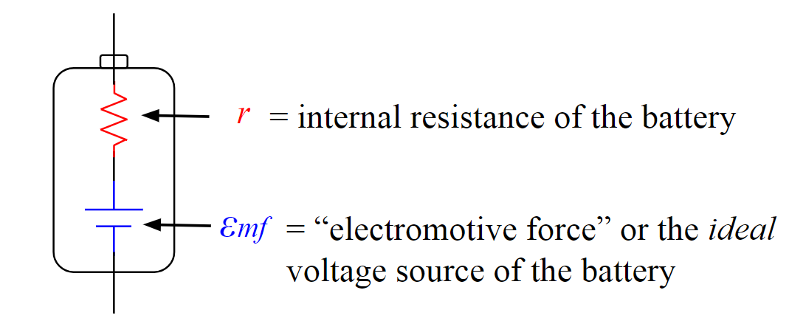

- Have student lab groups begin to use the following video to estimate the internal resistance of the battery and the Emf and document their data, analysis and any graphs on a large whiteboard to share with the class. Encourage advanced groups to find a way to graph their data and determine the Emf and internal resistance from a graph.
  - Video: Internal Resistance of a Battery Video

Day 2

- Have student groups finish using the following video to estimate the Emf and internal resistance of the battery and document their data, analysis and any graphs on a large whiteboard to share with the class.
  - Video: Internal Resistance of a Battery Video

- Handout a worksheet for individual students to work on once their lab group is finished with their whiteboard. This worksheet has the students solving complex circuit problems including one dealing with internal resistance.

- Once all student groups are finished finding the Emf and internal resistance of the battery, have the student groups present solutions and reach a general consensus about the internal resistance of a D cell battery → Is the internal resistance “ohmic”?

Day 3

- Check the homework for completion, and assign each student lab group one of the problems from assigned worksheet.
  - Each lab group should come to a consensus about their solution and record that solution on a large whiteboard. This should take between 10 and 15 minutes.
  - Have the student groups circle up and explain their solutions to their peers. Allow time for questions.

Formative Assessments: Link the items in the Activities that will be used as formative assessments.

This activity provides many opportunities for the teacher to formatively assess the students’ knowledge about the Emf and internal resistance of a battery. The teacher is able to walk around the classroom while students are using the video data to estimate the desired values. The students will also be verbally sharing their ideas with the class. This will provide additional opportunities for the teacher to formatively assess the students’ knowledge about the Emf and internal resistance of a battery.

Summative Assessments: These are optional; there may be summative assessments at the end of a set of Activities or only at the end of the entire Unit.

Content from this activity will be assessed on the post-test for the challenge based learning unit and the grading rubric for the design presentation. See the following documents.

- 1.0.0a Lithium Ion Batteries_Pre and Post Test_ADebbink
- 1.2.4f Lithium Ion Batteries_Presentation RUBRIC

Differentiation: Describe how you modified parts of the Lesson to support the needs of different learners.
Refer to Activity Template for details.

This activity gives different types of learners an opportunity to interact with the ideas in different ways. Hands-on learners will get to physically construct a circuit and physically take measurements on that circuit. Visual learners will be able to identify with the physical circuits during experimentation and the whiteboard illustrations of data collection and analysis for each group. Audible learners will benefit from the small and large group discussions with the circuit analysis. Regardless of learning style preference, all learners will benefit from having the information presented in various ways.

The nature of small group, collaborate work allows students who need more guidance to receive it. In small collaborate groups, the first place that students often receive help is from their peers. The teacher can also walk around listening to the student discussions and ask probing questions to help guide students toward a correct understanding. This allows the teacher to see where students are struggling and need extra guidance or help.

With this activity, the more advanced groups will be strongly encouraged to find the more difficult graphical solution to determine the Emf and the internal resistance of the battery.

Name: Aaron Debbink | Contact Info: akdebbink@gmail.com | Date: 07/03/2018

Lesson Title : Modeling Non-Ideal Batteries, Testing and Construction | Unit #: 1 | Lesson #:  2 | Activity #:  4
Activity Title: Battery Evaluation Design

Estimated Lesson Duration: | 10 days
Estimated Activity Duration: | 5 days

Setting: | Indian Hill High School, Room 118

Activity Objectives:

- The students will be able to create a procedure to test used lithium-ion cells.
- The students will be able to experimentally estimate the amount of usable capacity left a battery.
- The students will be able to experimentally estimate the internal resistance of a battery.
- The students will be able to refine a procedure to test used lithium-ion cells.
- The students will be able to formally present their refined procedure to test used lithium-ion cells.

Activity Guiding Questions:

- How can we determine the amount of electric charge stored in a battery?
- How can we measure the internal resistance of a battery?
- How can individual battery cells be tested in old battery packs?
- What are the quickest ways to determine if a lithium-ion battery cell has more usable life?
- What are the most reliable ways to determine if a lithium-ion battery cell has more usable life?

Next Generation Science Standards (NGSS)
Science and Engineering Practices (Check all that apply) | Crosscutting Concepts (Check all that apply)
☐ Asking questions (for science) and defining problems (for engineering) | ☐ Patterns
☐ Developing and using models | ☐ Cause and effect
☐ Planning and carrying out investigations | ☐ Scale, proportion, and quantity
☐ Analyzing and interpreting data | ☐ Systems and system models
☐ Using mathematics and computational thinking | ☐ Energy and matter: Flows, cycles, and conservation
☐ Constructing explanations (for science) and designing solutions (for engineering) | ☐ Structure and function.
☐ Engaging in argument from evidence | ☐ Stability and change.
☐ Obtaining, evaluating, and communicating information

Ohio’s Learning Standards for Science (OLS)
Expectations for Learning - Cognitive Demands (Check all that apply)
☐ Designing Technological/Engineering Solutions Using Science concepts (T)
☐ Demonstrating Science Knowledge (D)
☐ Interpreting and Communicating Science Concepts (C)
☐ Recalling Accurate Science (R)

Ohio’s Learning Standards for Math (OLS) and/or
Common Core State Standards -- Mathematics (CCSS)
Standards for Mathematical Practice (Check all that apply)
☐ Make sense of problems and persevere in solving them | ☐ Use appropriate tools strategically
☐ Reason abstractly and quantitatively | ☐ Attend to precision
☐ Construct viable arguments and critique the reasoning of others | ☐ Look for and make use of structure
☐ Model with mathematics | ☐ Look for and express regularity in repeated reasoning

Unit Academic Standards (NGSS, OLS and/or CCSS):

- 5.B.9.7: The student is able to refine and analyze a scientific question for an experiment using Kirchhoff’s Loop rule for circuits that includes determination of internal resistance of the battery and analysis of a non-ohmic resistor. [SP 4.1, 4.2, 5.1, 5.3]

Materials: (Link Handouts, Power Points, Resources, Websites, Supplies)

- Used lithium-ion battery packs – if you ask around enough you should be able to acquire used laptop or power tool batteries or they can be purchased in bulk from eBay
- Security Bit Set – this may be needed if opening power tool batteries.
- Zanflare C4 Smart Charger / Tester – This will be used to initially charge the individual lithium-ion cells once removed from the battery packs, before tested by students.
- 18650 Battery Cell Connectors - these are used to make electrical connections to the terminals of the individual lithium-ion cells.
  - abcGoodefg 1Slotx3.7V 18650 Battery Holder Case Plastic Battery Storage Box with Pin 10 Pack (10 Pcs 1 Solts) – these are the cheapest option, but will require soldered connections for testing.
  - Vruzend Solderless Connectors – these snap-on connectors use a bolt and nut to make the electrical connection to an external circuit without the need of soldering for testing or spot welding for making the final battery back.

- 1.2.4d Lithium Ion Batteries_Design Requirements
- 1.2.4e Lithium Ion Batteries_Presentation RUBRIC

Teacher Advance Preparation:

- You will need to obtain used laptop and / or power tool battery backs and safely disassemble them for students to test the individual lithium-ion cells. Each lab group will need at least 3 individual lithium-ion cells which came from the same battery pack. Watch the video below which shows how to disassemble a laptop battery to retrieve the individual lithium-ion cells. If you will be disassembling lithium-ion battery packs from power tools you may need to use a Security Bit Set.
  - Video: How to open Laptop Battery without destroying it | How to get 18650 Battery from laptop battery
- Use a wire cutter to cut any wires connected to the cells from any circuit boards. SAFETY: Only cut 1 wire at a time.
- Use needle nose plyers to remove the metal strips connecting the individual cells. SAFTEY: Be careful to only touch one battery terminal at a time with the plyers. Watch out for shorts!
- A small grinding wheel may be needed to finish removing the spot welds from the ends of the cylindrical cells.
- The individual cells will need to be initially charged with a lithium-ion cell charger before tested by students. SAFTEY: Use only a battery charger which is designed to charge lithium-ion batteries.
  - I would recommend using the Zanflare C4 Smart Charger / Tester.
- Label and place the individual cylindrical cells from each battery pack in a separate zip lock bag. Each lab group will receive one bag for testing. The following is a suggested naming convention.
  - “P1A” – Power tool battery, battery pack #1, battery A
  - “L3B” – Laptop battery, battery pack #3, battery B.
  - The following image shows how the cells were labeled which came from the 1st disassembled battery pack from a power tool.
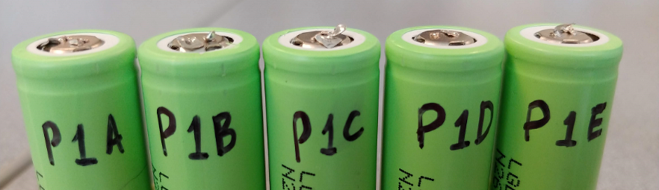

Activity Procedures:

Day 1

- Handout the Battery Testing Documentation Requirements (1.2.4d Lithium Ion Batteries_Design Requirements) and discuss the naming convention, sharing requirements, formatting, and general overview of the required sections.
  - The student will be creating a Google Doc to document their testing process, data collection and revisions throughout the activity. This documentation will be graded and will also be used by each lab group to help create a presentation of their design process and overall conclusions.

- Explain section #1 and #2 in detail. The students will be required to complete these sections before testing individual lithium-ion cells. See below for section #1 and section #2 requirements.
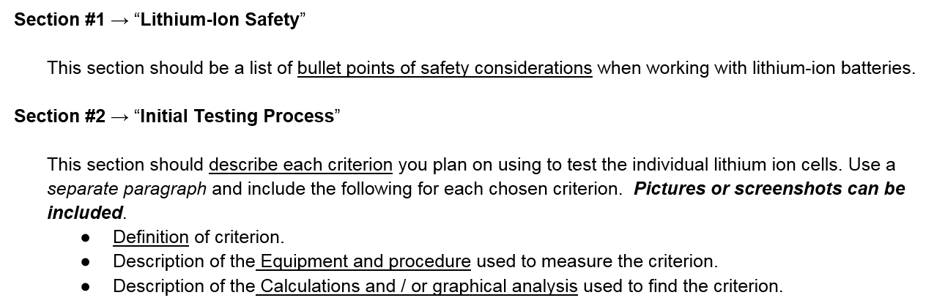

- Students will use the remainder of the period completing sections #1 and #2. This will be homework if not completed in class.

- Check section #1 and #2 for any group which finishes during class time. Hand out a bag of lithium-ion cells to each lab group once the sections are approved.
  - The individual cells should be kept in the classroom during the project in case students are absent.

Day 2

- Check section #1 and #2 from the remaining lab groups. Hand out a bag of lithium-ion cells to each lab group once the sections are approved.

- The students should test 1 or 2 cells using their initial testing criteria and record the data and analysis in their Google Doc. See below for section #3 requirements.

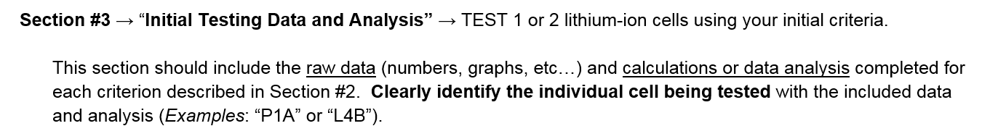

- Each student group should prepare a large whiteboard to give a progress report to the class. The progress report should include initial testing criteria, procedures, and preliminary data to be shared with the class at the beginning of the next class period.

Day 3

- Have each lab group share their progress report with the class. Allow time for questions.

- Give students time to consider their initial process and their peers’ progress reports. Students should refine their battery testing process by either adding or removing testing criteria or modifying a testing procedure for one of the initial criterion. The explanation of any revisions should be included in section #4 in the Google Doc. The final revised testing process should be documented in section #5. See below for section #4 and section #5 requirements.
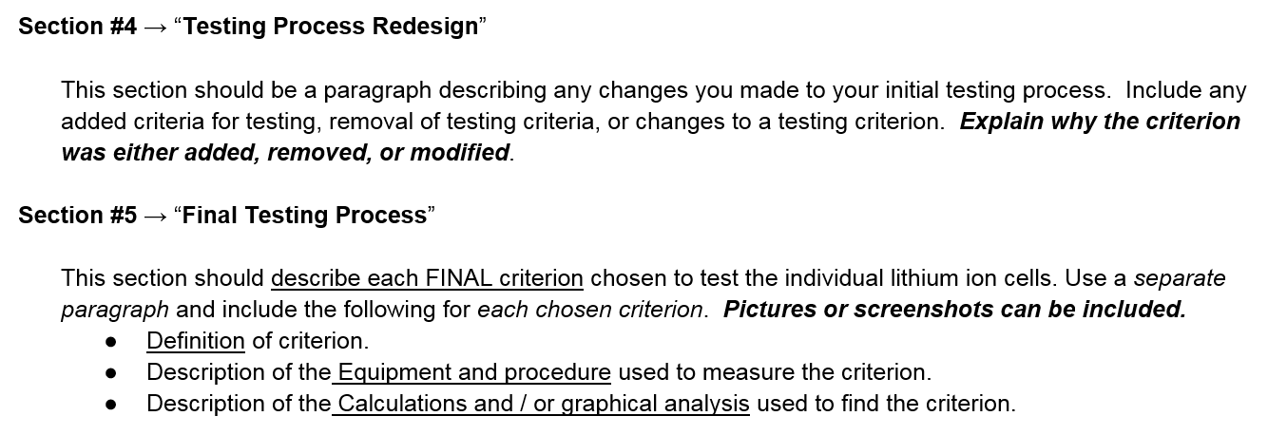

- Students should continue testing at least 2 additional cells with their revised testing process. The data and analysis should be documented in section #6 on their Google Doc. See below for section #6 requirements.

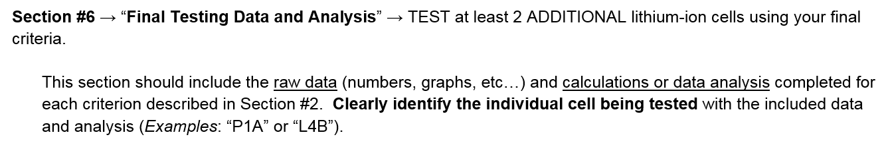

Day 4

- Discuss with the students that they will be presenting their design process for battery evaluation to the class. Handout and discuss the presentation grading rubric (1.2.4e Lithium Ion Batteries_Presentation RUBRIC). This discussion could also happen on day 3 so students can work on the presentation during any wait time while battery testing.

- Students should finish testing 2 or more additional cells using their final testing process. The data and analysis should be documented in section #6 on their Google Doc.

  - The students should work on the presentation during any wait time while battery testing.
Day 5

- Students present their design process for battery evaluation using a Google Slides file.
  - Use the presentation rubric for grading. (1.2.4e Lithium Ion Batteries_Presentation RUBRIC)

Formative Assessments: Link the items in the Activities that will be used as formative assessments.

This activity provides many opportunities for the teacher to formatively assess the students’ knowledge about batteries, energy storage, and internal resistance. The teacher is able to walk around the classroom and passively observe while students are designing and evaluating their battery testing process. The teacher can also actively ask questions to probe for understanding. The students will also be verbally sharing their ideas with the class both informally and formally. This will provide additional opportunities for the teacher to formatively assess the students’ knowledge about batteries, energy storage, and internal resistance.

Summative Assessments: These are optional; there may be summative assessments at the end of a set of Activities or only at the end of the entire Unit.

The engineering design process which is a part of this activity will be assessed with the grading rubric for the design presentation. See the following document.

- 1.2.4e Lithium Ion Batteries_Presentation RUBRIC
Differentiation: Describe how you modified parts of the Lesson to support the needs of different learners.
Refer to Activity Template for details.

This activity gives different types of learners an opportunity to interact with the ideas in different ways. Hands-on learners will get to physically construct a circuit and physically take measurements on that circuit. Visual learners will be able to identify with the physical circuits during experimentation, the whiteboard illustrations of data collection and analysis for each group, and the final presentations. Audible learners will benefit from the small and large group discussions during the entire design process. Regardless of learning style preference, all learners will benefit from having the information presented in various ways.

The nature of small group, collaborate work allows students who need more guidance to receive it. In small collaborate groups, the first place that students often receive help is from their peers. The teacher can also walk around listening to the student discussions and ask probing questions to help guide students toward a correct understanding. This allows the teacher to see where students are struggling and need extra guidance or help.

Name: Aaron Debbink | Contact Info: akdebbink@gmail.com | Date: 07/03/2018

Lesson Title : Modeling Non-Ideal Batteries, Testing and Construction | Unit #: 1 | Lesson #:  2 | Activity #:  5
Activity Title: Battery Pack Construction

Estimated Lesson Duration: | 10 days
Estimated Activity Duration: | 2 day

Setting: | Indian Hill High School, Room 118

Activity Objectives:

- The students will be able to construct a battery pack with used lithium-ion cells.

Activity Guiding Questions:

- How can we use the used cells in a dead battery back?

Next Generation Science Standards (NGSS)
Science and Engineering Practices (Check all that apply) | Crosscutting Concepts (Check all that apply)
☐ Asking questions (for science) and defining problems (for engineering) | ☐ Patterns
☐ Developing and using models | ☐ Cause and effect
☐ Planning and carrying out investigations | ☐ Scale, proportion, and quantity
☐ Analyzing and interpreting data | ☐ Systems and system models
☐ Using mathematics and computational thinking | ☐ Energy and matter: Flows, cycles, and conservation
☐ Constructing explanations (for science) and designing solutions (for engineering) | ☐ Structure and function.
☐ Engaging in argument from evidence | ☐ Stability and change.
☐ Obtaining, evaluating, and communicating information

Ohio’s Learning Standards for Science (OLS)
Expectations for Learning - Cognitive Demands (Check all that apply)
☐ Designing Technological/Engineering Solutions Using Science concepts (T)
☐ Demonstrating Science Knowledge (D)
☐ Interpreting and Communicating Science Concepts (C)
☐ Recalling Accurate Science (R)

Ohio’s Learning Standards for Math (OLS) and/or
Common Core State Standards -- Mathematics (CCSS)
Standards for Mathematical Practice (Check all that apply)
☐ Make sense of problems and persevere in solving them | ☐ Use appropriate tools strategically
☐ Reason abstractly and quantitatively | ☐ Attend to precision
☐ Construct viable arguments and critique the reasoning of others | ☐ Look for and make use of structure
☐ Model with mathematics | ☐ Look for and express regularity in repeated reasoning

Unit Academic Standards (NGSS, OLS and/or CCSS):

- This particular activity does not address specific academics standards for AP Physics 2.

Materials: (Link Handouts, Power Points, Resources, Websites, Supplies)

- 18650 Battery Cell Connectors (from Activity #4)
- Black Wire
- Red Wire
- Wire Cutters
- Wire Strippers
- Electrical Tape
- Soldering Iron
- Solder with Flux
- Heat Shrink Wrap
- Heat Gun for Shrink Wrap
- Micro USB Charging Protection Circuit – This allows the constructed lithium-ion battery pack to be charged with a micro USB charging cable. This provides charging protection, so the battery pack is not over charged.
- DC to DC Boost Converter with USB Output – This allows the battery pack to provide a constant 5V output so that it can charge anything that plugs into a standard USB port. This also provides discharge protection for the battery pack using a low voltage cutoff.
- USB to Micro USB Charging Cables – this is needed to charge the battery pack from a standard USB port.
- 10 Port USB Charging Hub – this will be used to charge all of the constructed battery packs.
- Lithium Solar Charger – this is used to charge a larger battery pack with a variable voltage source such as solar panels or a bicycle generator.

Teacher Advance Preparation:

The teacher should use assemble an example battery pack using a 1 or multiple lithium-ion cells in parallel which can be charged using a standard USB port and can then be used to charge another device with its own USB charging port. (FUTURE: An example image will be included below)

Activity Procedures:

Day 1

- Discuss how the students will use their tested cells which have usable life to make a battery pack which can charge any device using a USB plug (cell phone, tablet, small drone, etc…)
- Discuss the construction basics listed below.
  - The Micro USB Charging Protection Circuit is used to protect the battery from overcharge, more than 4.2V. It also allows the battery to be charged using a micro USB cable.
  - The DC to DC Boost Converter with USB Output allows the 4.2 – 2.5V battery pack to provide a constant 5V output so that it can charge anything that plugs into a standard USB port. This also provides discharge protection for the battery pack using a low voltage cutoff so the battery will stop discharging when the voltage reaches 2.5V.
  - Demonstrate how to use a soldering iron to make the electrical connection between the lithium-ion battery holder and the charging and discharge circuits.
  - Use red wire for the positive battery terminals and black wire for the negative battery terminals.
  - Cover the exposed soldered connections with electrical tape to prevent shorts.

- Have the lab groups use the micro USB charging cables and the 12 Port USB Charging Hub to charge fully charge their battery pack.
Day 2

- Have the students disconnect their fully charged battery pack and test it by charging their cell phone.

Formative Assessments: Link the items in the Activities that will be used as formative assessments.

This activity provides several opportunities for the teacher to formatively assess the students as they construct their battery pack. The teacher is able to walk around the classroom while students are constructing the battery pack to assess their understanding of the battery pack design and their ability to use solder to make electrical connections.

Summative Assessments: These are optional; there may be summative assessments at the end of a set of Activities or only at the end of the entire Unit.

There will be no summative assessments for this activity.

Differentiation: Describe how you modified parts of the Lesson to support the needs of different learners.
Refer to Activity Template for details.

This activity gives different types of learners an opportunity to interact with the ideas in different ways. Hands-on learners will get to physically construct the battery pack using their tested lithium-ion cells. Visual learners will be able to identify with the sample battery pack. Audible learners will benefit from the verbal presentation of construction steps given by the teacher. Regardless of learning style preference, all learners will benefit from having the information presented in various ways.

The nature of small group, collaborate work allows students who need more guidance to receive it. In small collaborate groups, the first place that students often receive help is from their peers. The teacher can also walk around listening to the student discussions and ask probing questions to help guide students toward a correct understanding. This allows the teacher to see where students are struggling and need extra guidance or help.

